May 2023

**Automatically Generated Large Scale Alien Planets**

MComp Computer Science (Game Engineering)

Joshua Frost | 200445140

Supervisor: Dr Gary Ushaw

# **Abstract**

This dissertation will document the research, development and testing of a procedural planet generation tool, covering the underlying theory of the techniques used as well as details of their application to the project.

A summary of relevant background information is presented with a focus on noise functions, followed by documentation covering the design and implementation of the planet tool. Benchmark testing results are presented to show the performance of the tool in terms of frames per second under different conditions, along with a discussion of the achievements of the project and plans for future work to further it.

# **Declaration**

“I declare that this dissertation represents my own work except where otherwise stated.”

# **Acknowledgements**

I would like to thank the supervisor of this project Dr Gary Ushaw for allowing the project to be undertaken, as well as for providing continued support throughout. He has helped with organisation and has always been able to offer helpful advice. Thanks are also given to Dr Rich Davison and Dr Giacomo Bergami, who have also provided help and guidance during the project.

**Table of Contents**

**Abstract** 1

**Declaration** 2

**Acknowledgements** 3

**Table of Figures** 6

**1. Introduction** 8

1.1 Motivation 8

1.2 Aims and Objectives 8

1.3 Justification of Objectives and Structure 9

1.4 Dissertation Outline 10

**2. Background Review** 12

2.1 Research Process 12

2.2 Introduction to Noise 13

2.3 Noise Functions 14

2.3.1 Value Noise 14

2.3.2 Diamond-Square Noise 15

2.3.3 Perlin Noise 15

2.3.4 Simplex Noise 17

2.4 Application To Terrain Generation 19

2.4.1 2D Noise For Terrain 20

2.4.2 3D Noise For Planets 20

2.5 Summary and Evaluation of Sources 21

**3. Design and Implementation** 23

3.1 Overview of Section 23

3.2 Planning 23

3.2.1 Software Development Model 23

3.2.2 Tools Used 24

3.3 Design Requirements 24

3.4 Prototyping of Sphere Generation Techniques 25

3.4.1 Sphere Generation Requirements 25

3.4.2 UV Spheres 25

3.4.3 Cube Spheres 27

3.4.4 Icospheres 29

3.4.5 Conclusions of Prototyping 31

3.5 Implementation Of Planet Tool 31

3.5.1 Noise Function and Layers 31

3.5.2 Level of Detail System 33

3.5.3 Overlapping Triangles 36

3.5.4 Planet Settings 39

3.5.5 Optimisations and Improvements 41

3.6 Testing Methodology 42

3.6.1 Benchmark Script 42

3.6.2 Hardware 44

3.6.3 Testing Strategy 44

3.6.4 Default Settings 44

**4. Results and Evaluation** 46

4.1 Format of Tool 46

4.2 Results 47

4.2.1 Stationary Benchmarks 47

4.2.2 Movement Benchmarks 50

4.2.3 Noise Function Comparison 54

4.3 Evaluation 55

**5. Conclusions** 56

5.1 Satisfaction of Aim and Objectives 56

5.2 Reflection and Personal Development 57

5.3 Future Work 58

**References** 59

**Appendix A** 62

**Appendix B** 64

# **Table of Figures**

**2. Background Review**

Figure 1: The texture mapping process [3] 13

Figure 2: Random white noise (left) vs noise (right) [2] 13

Figure 3: Bilinear interpolation between 4 grid points 14

Figure 4: Diamond-Square process [6] 15

Figure 5: Diagram of the 12 gradients recommended for 3D noise [9] 16

Figure 6: Comparison of 1D Perlin vs Value Noise [10] 16

Figure 7: Comparison of Hypercubes (left) and Simplices (right) in n dimensions [12] 17

Figure 8: Diagram and explanation of radial attenuation for Simplex Noise [9] 18

Figure 9: Diagram showing the locating of simplex corners 18

Figure 10: Elements of a polygonal model [14] 19

Figure 11: Plane within the Unity game engine [15]…………………………………………………………………………19

Figure 12: Generated terrain within Unity [16]………………………………………………………………………………..19

Figure 13: Visualisation of generated terrain [31] 20

Figure 14: Heightmap image generated with Perlin Noise [17] 20

Figure 15: 3D Simplex Noise applied to a sphere [19] 21

**3. Design and Implementation**

Figure 16: The standard iterative waterfall model (left) versus the modified model used for the project (right) 24

Figure 17: Generated UV sphere with 30 rings and 60 segments 26

Figure 18: Generated cube sphere with a resolution of 20 28

Figure 19: Relationship between resolution and the number of triangles required per face 28

Figure 20: The generated icosahedron being subdivided to represent a sphere 30

Figure 21: The triangle subdivision process 30

Figure 22: Planet generated with Simplex Noise 32

Figure 23: Planet with high roughness……………………………………………………………………………………………..33

Figure 24: Planet with low roughness………………………………………………………………………………………………33

Figure 25: Generated planet with player camera at distances of 70, 30, 10 and 2 units from surface .34

Figure 26: Generated planet with its 6 Cube Sphere faces spaced out 34

Figure 27: Level of detail system shown on a sphere 35

Figure 28: Diagram showing the relationship between the vertex indices in each triangle 38

Figure 29: The same generated planet, before and after the overlapping triangles fix 38

Figure 30: Screenshot of Planet script settings in inspector tab 39

Figure 31: Generated planet shown with increasing chunk resolution from 5 to 8 39

Figure 32: Screenshot of demonstration scene with navigable camera 40

Figure 33: Screenshot of Unity gradient editor with example planet colour data 40

Figure 34: Benchmark script settings 43

Figure 35: Screenshot of the Unity console output after performing a benchmark 43

Figure 36: Screenshot of planet generated with default settings 45

**4. Results and Evaluation**

Figure 37: Screenshot of Planet script settings in inspector tab 47

Figure 38: Screenshot of stationary benchmark results at 80 units distance 47

Figure 39: Screenshot of stationary benchmark results at 40 units distance 48

Figure 40: Screenshot of stationary benchmark results at 20 units distance 48

Figure 41: Screenshot of stationary benchmark results at 10 units distance 49

Figure 42: Chart showing average FPS in stationary benchmark, with SOC disabled 49

Figure 43: Chart showing average FPS in stationary benchmark, with SOC enabled 50

Figure 44: Chart showing average FPS in movement benchmark, with different planet settings configurations 51

Figure 45: Chart showing average FPS in movement benchmark, with different numbers of noise layers 52

Figure 46: Chart showing average FPS in movement benchmark, with different benchmark settings. 53

Figure 47: The default planet at chunk resolutions of 2, 4, 6, 8, 10 and 12, with the player camera…80 units away 53

Figure 48: Chart showing average FPS in movement benchmark, with different noise configurations 54

# **1. Introduction**

## Motivation

The games industry is an ever-growing behemoth that has become a huge part of popular culture, and as the industry grows so does the demand for larger and more detailed game worlds, as the standards and expectations placed on modern games continue to rise. Buzzwords and phrases such as ‘open world’, ‘immersive’ and ‘sandbox’ are frequently used to attract potential players, and big-budget development studios continue to push the boundaries of how well they can deliver on these claims. This desire for constant improvement has led to the development of tools that can optimise the process of creating game environments, and procedural generation is a key technology that can be used to automate that process to varying extents. Procedural tools can be used for a wide range of applications by artists and designers, from automatically creating varied and detailed terrain at the click of a button, to providing an in-engine brush that can paint cliffs, roads or trees onto that terrain. As such, there is a significant demand for these tools as well as for specialists that can create and tailor them to the specific needs of a game or development studio.

The space sandbox genre of games naturally demands huge and diverse galaxies or universes, where the sheer quantity of content required for a convincing representation of space is simply impossible for designers to manually create. This is a perfect use case for procedural generation, as it can be applied to combat this problem of scale which is increasingly prevalent within the development of modern game worlds. It can be utilised either via tools to help speed up the design workflow, or via entire systems that generate the game environment from scratch such as in ‘No Man’s Sky’, with its “procedurally generated deterministic open universe that contains a staggering 18.4 quintillion planets” [1]. For this game a proprietary engine was used, but the concept has inspired many to aim to create similar experiences in popular engines such as Unity. Some tools for procedural planet generation within Unity do exist, but all current solutions are either extremely primitive and cannot easily be scaled up, or are so feature-rich and specific that they would require a total rework to be able to be used in combination with other systems in a complex game.

In order to provide a solution to the aforementioned problem of scale, this dissertation will cover the creation of a tool to automatically generate large-scale planets that can be quickly and easily created and edited, demonstrating the strengths of procedural generation within the Unity engine. These planets could be used on their own as the foundations of a game world, or be combined to form solar systems that can be visited in a fully fleshed-out space sandbox game. This solution will differ to the existing implementations by being sufficiently powerful, efficient and scalable to be useful for those types of games, while also being customisable and easy to use due to the intuitive way in which it will work, as well as the extensive documentation in the form of this dissertation. Therefore it will meet the needs of both aspiring and established developers aiming to create a game within the space genre.

## Aims and Objectives

**Aim:** To create a procedural tool to automatically generate large-scale alien planets within the Unity game engine, and demonstrate its use and features while maintaining a consistent frame rate on mid-range gaming computers.

**Objectives:**

1. Analyse the algorithms and techniques used in literature and in existing implementations of procedural mesh and terrain generation to inform the development of the tool

2. Implement a procedural planet generation tool within the Unity game engine

3. Demonstrate the planet tool features by creating a menu where the planet settings can be edited, with changes showcased in real time within a navigable demonstration scene

4. Optimise the generation and rendering of the planets to be as efficient as possible so that a consistent frame rate can be maintained at runtime

## 1.3 Justification of Objectives and Structure

The aim clearly states the intended outcome of the project, and this overall goal can be broken down into 4 objectives which are all key to its fulfilment. The first objective is research-based, and involves looking at current research and discussion surrounding the field of procedural generation to build an understanding of the kinds of methods required in order to achieve the aim. This objective will be primarily covered in the ‘Background’ section of this dissertation, and is the foundation of the project that provides me with the required understanding to successfully fulfil the aim.

Objective 2 is the implementation aspect of the project, where the knowledge acquired will be used to create the procedural planet generation tool. This is naturally the most crucial aspect of the overall aim, as it is where the piece of software at the core of this project will be produced. The objective is intended to be a high-level statement, and the specific requirements and details of the implementation will be covered in the ‘Design and Implementation’ section.

The third objective gives an opportunity to focus on the usability of the tool, as well as ensuring its output planets are suitable for their intended purpose of being included within a playable game. It was altered from the original project proposal, where the plan was to instead create a procedural solar system generator in order to showcase the planet tool. This was overly ambitious for the constraints of this project, and a decision was swiftly made to instead demonstrate the tool via a simple demonstration scene with a settings menu that caused real-time changes.

Objective 4 focuses on the performance of the tool, as it is a crucial part of the aim that a consistent frame rate can be maintained on mid-range gaming hardware while a planet is demonstrated. Details of relevant design decisions and optimisations made to the solution will be explained in the ‘Design and Implementation’ section along with a breakdown of the testing process, and the effectiveness of the efforts made will be discussed in the ‘Results and Evaluation’ section later on. This evaluation will be based on the performance of the tool under different conditions, with the primary metric being average frames per second achieved. This is to determine the effect of each setting on performance, and whether the tool is suitable for use by developers to create playable game environments.

## 1.4 Dissertation Outline

A brief overview of the dissertation structure, which is divided into sections based on the objectives and reasoning described in the previous section.

**Introduction**

*An introduction to the context and motivation of the project, and an explanation of its aim and objectives*

* Motivation
* Project Aim and Objectives
* Justification of Objectives and Structure
* Dissertation Outline

**Background Review**

*The research undertaken as part of the project, to build an understanding of the methods and techniques that can should be used in development*

* Research Process
* Introduction to Noise
* Noise Functions
* Application To Terrain Generation
* Summary and Evaluation of Sources

**Design and Implementation**

*What was done in the project and how, detailing the methods used and key decisions made*

* Overview of Section
* Planning
* Design Requirements
* Prototyping of Sphere Generation Techniques
* Implementation of Planet Tool
* Testing Methodology

**Results and Evaluation**

*Presentation, analysis and evaluation of the project outputs and testing results*

* Format of Tool
* Results
* Evaluation

**Conclusions**

*Assessment of the achievements of the project and overall process, drawing conclusions based on evidence and fulfilment of aim and objectives*

* Satisfaction of Aim and Objectives
* Reflection and Personal Development
* Future Work

# **2. Background Review**

## 2.1 Research Process

This section presents the research undertaken during the project, which contributes to the first main objective and was therefore crucial in enabling the development of the procedural planet tool. The research process began with a general assessment of the project domain, which concluded that the primary focus should be noise functions and their application to terrain generation due to their fundamental role in the process. This background review will cover the findings of this research, and evaluate the validity and relevance of the various sources that informed those findings. Research was conducted using both proven published research, and informal sources.

Published research sources:

* Research papers on noise functions and procedural generation techniques, found through the Newcastle University library search tool, and the use of Google Scholar
* Articles covering introductions to noise techniques, and implementation-based details relevant to the project. Found through targeted online searching within the project topic
* Manuals and documentation of functions related to the project, found through previous awareness of the source such as the Unity User Manual and Scripting API, or through links or references from informal sources

Informal sources, found through specific online searches:

* Online blogs and informal articles where the implementation or comparison of various noise function was covered
* Public forum posts seeking help with implementing or choosing between noise functions

## 2.2 Introduction to Noise

Within the context of computer graphics, noise is a sequence of pseudo-random floating point values that is generated by noise functions, and is a widely used technique within the field for a range of applications. The concept of using noise instead of images for texturing objects was developed in the mid-1980s, replacing the process known as texture mapping which was proving increasingly problematic due to memory constraints at the time [2].

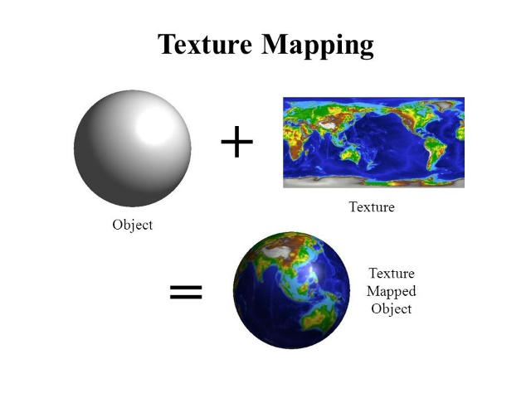

Figure : The texture mapping process [3]

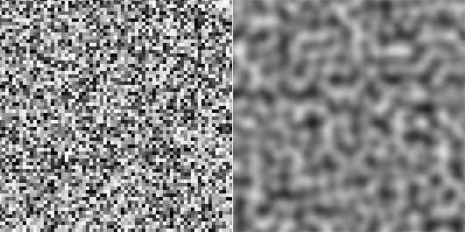Randomness could be used to break up the uniformity of a solid colour by varying its properties across the surface, as an alternative to texture mapping. While random number generators are commonly used to create randomness in programming, they do not work well for adding variation to the appearance of 3D objects. This is because they are designed to produce values that have no discernible pattern or relationship, which makes them unsuitable for texturing visual elements in a realistic way. The random patterns found in nature are usually smooth, and two points on the surface of a real object that are close to each other typically look similar, while two points far apart can look very different. A smoother distribution of values is needed to emulate this, making true randomness completely unsuitable. Instead, noise can be used to give a more natural looking distribution, while still requiring very little memory as the individual pixel values are computed with noise functions, rather than being stored.

Figure : Random white noise (left) vs noise (right) [2]

## 2.3 Noise Functions

Noise functions are real-valued functions that vary between 0 and 1 over some domain [4]. The domain can be defined for any number of dimensions to be suitable for the given application, and the noise is generated by determining a pseudo-random number within the domain. Regardless of the number of dimensions the function is defined for, the output will always be a floating point value in the range 0 to 1, which can be transformed if needed and then mapped to an output such as colour or brightness within a texture. There are several types of noise that are generated via different methods, and this section will cover the most relevant functions to the project.

### 2.3.1 Value Noise

Value Noise works by setting a grid across a surface, and assigning each grid point a random value [2]. The value of each pixel in between these grid points is an interpolation between the closest grid points, with the number of points to interpolate between depending on the dimensions of the noise. 1D Value Noise interpolates between two points, 2D between four points, and so on, with the number of points being equal to the number of dimensions squared. The closest grid points are found by rounding the local coordinates of the pixel up and down to integer values, usually using a floor function.

Value Noise makes use of a random number generator for the grid point values, and if a deterministic generator function is used then the random values can be calculated in real-time using grid coordinates, and the grid does not need to be stored in memory. This means that almost no memory is needed, and individual pixel values can be calculated independently for rendering [5].

The function used to interpolate between the grid points greatly affects performance, with linear interpolation (LERP) giving fast but lower quality results containing jagged lines. Cosine interpolation is slower with rounded results, and cubic interpolation gives the best results but is by far the slowest method [5]. For creating noise maps in real-time, linear interpolation must be therefore be used for performance reasons, despite compromising on quality. LERP is one-dimensional but can be repeatedly used for higher dimensions, such as bilinear interpolation in 2D which works by using LERP in one direction, then linearly interpolating again between the results to give the final value.

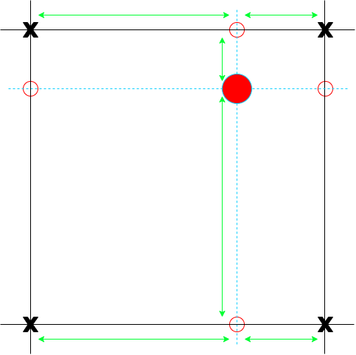

Figure : Bilinear interpolation between 4 grid points

### 2.3.2 Diamond-Square Noise

The Diamond-Square algorithm is used to generate a square noise grid by setting the corner points to random initial values, and then performing the diamond and square steps alternately down to a set level of detail [5]. Each iteration the level of detail is increased, and the range of random values is decreased leading to smaller details being added each step. The steps are as follows:

* Diamond step: for each square in the grid at the current detail level, the midpoint value is set to the average of the four corner points plus a random error value within a given range
* Square step: for each diamond in the grid at the current detail level, the midpoint value is set to the average of the four corner points plus a random error value within a given range

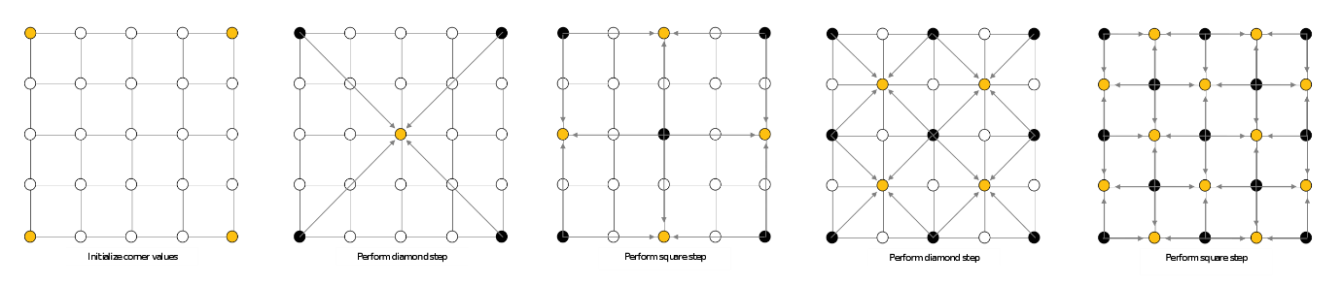

Figure : Diamond-Square process [6]

For the edge cases, specifically the calculations for edge points during the square step, only three values are available to average. This average can be taken to produce good results, but an alternative option is to take a fourth value from the other side of the array, meaning the grid will wrap around and separate identical grids could be seamlessly combined. This is useful for some texture applications where the texture needs to be tiled, such as a brick wall.

Diamond-Square Noise is high quality, despite the algorithm being extremely fast and simple to implement. The main drawback of using Diamond-Square Noise is that the entire grid image must be stored in memory, because pixels need to access neighbouring values.

### 2.3.3 Perlin Noise

Perlin Noise is the most well-known and popular algorithm for procedural generation [7], and is still considered by many as the industry standard despite the subsequent release of a faster algorithm by creator Ken Perlin. It shares some similarities with Value Noise, starting with the use of an arbitrary grid, and the interpolation used to calculate pixel values based on their distance from nearby grid points. Instead of height values at each grid point though, Perlin Noise uses gradient vectors that influence nearby pixels with a force, and it therefore falls within the category of gradient noise [5].

Instead of using a random number generator as in Value Noise, Perlin Noise [8] makes use of a permutation table of size *n*, containing the numbers 0 through *n-1* which are randomly shuffled. A typical value for *n* is 256 for a 2D image. A gradient table is also used, which contains vectors pointing in pseudo-random directions that are equally spaced. This table is comparatively very small, with 8 or 16 gradients distributed around a unit circle being considered a good choice for 2D implementations, and Ken Perlin himself recommending just 12 entries for 3D noise: the midpoints of each of the 12 edges of a cube centred on the origin [9].

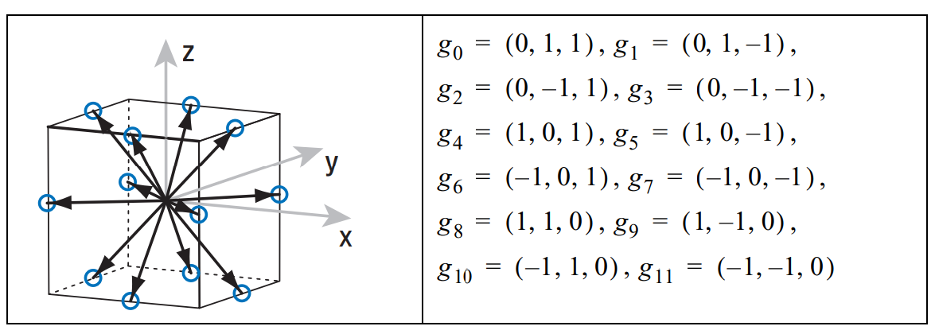

Figure : Diagram of the 12 gradients recommended for 3D noise [9]

To generate a pixel value with Perlin Noise, the following steps are taken:

1. Find the surrounding grid points by rounding the local pixel coordinates up and down as in Value Noise, and use their coordinates to find their associated gradients. This is done by using the formula:



1. For each grid point, get the dot-product between its gradient and the distance vector to the point from the pixel.
2. Linearly interpolate between the dot-product values found in step 2.

The array indexing used in step 1 is an extremely fast operation compared to the multiplication, division and prime numbers typically used by random number generators. Overall the function is slower than Value Noise due to the additional steps involved, which is itself slower than Diamond-Square Noise [5]. The high quality of Perlin Noise makes the trade-off worthwhile though, as the noise produced is to a great standard while also maintaining the level of control present in Value Noise. The use of gradients means that flat curves are less likely, so nearby values will consistently have more variety rather than some areas of the image having small changes and some areas having large ones [10]. With Value Noise this is much more likely as values are interpolated between rather than gradients, and there is a higher chance that some regions will contain similar values.

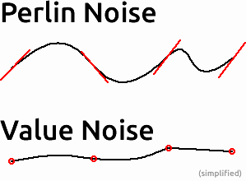

Figure : Comparison of 1D Perlin vs Value Noise [10]

### 2.3.4 Simplex Noise

Simplex Noise was also created by Ken Perlin, and was released in 2001 to replace his older algorithm due to its faster performance at higher dimensions [11]. Perlin Noise is exponential time complexity with *O(2n*) where *n* is the number of dimensions, whereas Simplex Noise is *O(n2)* which is polynomial time [9]. This explains why Perlin Noise is much slower at higher dimensions, as exponential time complexity algorithms grow much faster than polynomial time.

This improvement was achieved by resolving two limitations of Perlin Noise: the use of a hypercube for the grid, and the use of linear interpolation which only works in one dimension [5]. A hypercube is a geometric figure in Euclidian space of *n* dimensions which is analogous to a cube in three dimensions, and therefore has *2n*corners, so *2n* grid points for each pixel to use. *2n – 1* linear interpolations are needed for each pixel, because you must interpolate in one dimension at a time as described for Value Noise. These two features give Perlin Noise its exponential time complexity.

Instead of hypercubes Simplex Noise uses simplices, which is the shape with the fewest corners in a given dimension. This means that in 2D a triangle is used rather than a square, and in 3D it uses a pyramid rather than a cube. In general a simplex has *n+1* corners, which is far less than *2n* at higher dimensions. This is evident in the image below, where the number of vertices, or corners, is denoted as ‘V’ and is shown to grow exponentially for hypercubes but linearly and therefore much more slowly for simplices.

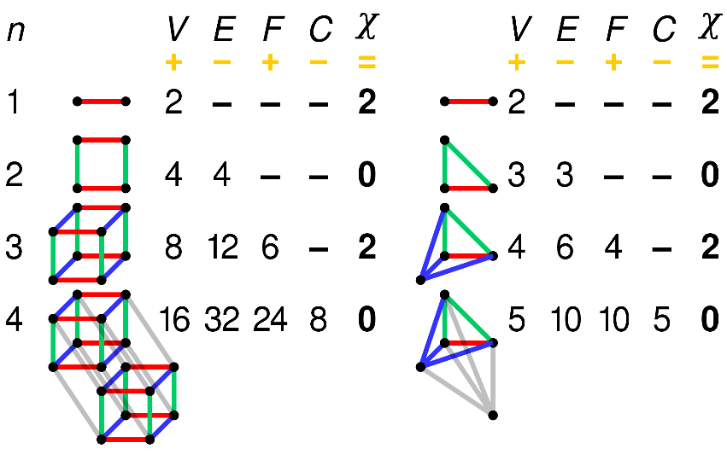

Figure : Comparison of Hypercubes (left) and Simplices (right) in n dimensions [12]

To fix the second weakness, a radial attenuation function is used in place of linear interpolation to calculate pixel values. The radial attenuation function is chosen in a way that ensures that the impact of each corner diminishes to 0 before crossing the boundary to the next simplex. As a result, only the contributions from the corners of a specific simplex will influence the points inside it, and not the corners of other simplices. These contributions are summed instead of interpolated between, due to the nature of radial attenuation. Only *n+1* radial attenuations are required, so these two changes bring the overall complexity of Simplex Noise down to exponential time [9].

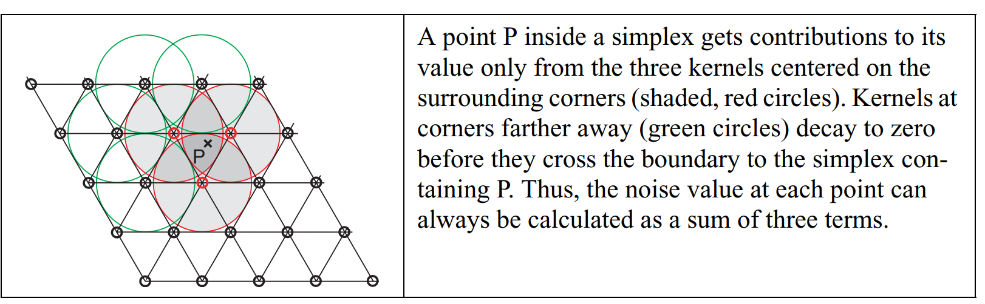

Figure : Diagram and explanation of radial attenuation for Simplex Noise [9]

However, these changes make it considerably more complex to find the nearest grid points for a given pixel. As you are now working with simplices rather than hypercubes, you cannot simply round the pixel coordinates up and down to find the closest grid points, and you must first skew the simplex grid until it resembles a grid of n-dimensional hypercubes. You can then find the grid coordinates as usual to determine which hypercube a pixel is in, but you must also find which specific simplex it is in within the hypercube, as each is made up of two simplices. This can be done in 2D by comparing the magnitudes of the relative x and y coordinates, as if the x value is greater than the y value then the pixel is in the lower-right simplex, and the third corner can be found by rounding the x value up and the y value down. This process is reversed if the y value is greater than the x value, and the method can be extended to higher dimensions. The three corners (or more for higher dimensions) are then each associated with a gradient using the same equation as in step 1 of Perlin Noise.

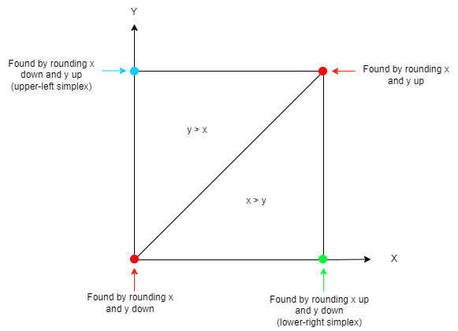

Figure : Diagram showing the locating of simplex corners

Simplex Noise is an objective improvement over Perlin Noise but is still yet to be widely adopted as it is much more complex to understand, and the improvements are often negligible as most uses are in 2 or 3 dimensions. For most users there is simply no need to switch to using Simplex noise, despite it being faster in general and producing higher quality results.

However one advantage which is significant for some uses is that Simplex Noise has no noticeable directional artifacts, making it visually isotropic. Isotropic means uniform in all directions, so the angle of the noise would be impossible to discern if rotated, which may be a requirement for some specific purposes within games, such as certain textures.

## 2.4 Application To Terrain Generation

Procedural terrain generation is the process of using automated systems and pseudo-random algorithms to create terrain for games or other digital media [13], instead of designers and artists producing it manually. This streamlines and speeds up the design process, making the creation of detailed environments much more efficient.

Terrain is fundamentally a 2D or 3D model, and is based on a mesh that gives its shape. A mesh is an aspect of a model that represents the structure of an object, and is made up of vertices that are connected by primitives to form polygons. Vertices are the points at which the edges of the object meet, polygons make up the faces of the object, and primitives are the chosen shape of polygon to use, such as triangles. In order to generate terrain procedurally, a set of vertices must therefore be created, positioned and connected using a chosen primitive type to form a mesh.

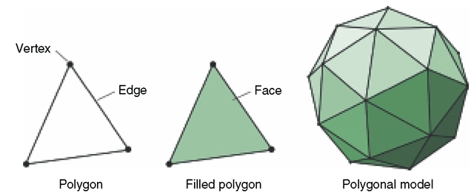

Figure : Elements of a polygonal model [14]

The required terrain is often a large surface where the elevation needs to be varied and interesting, particularly for games where it will be navigated and explored by players. This means that the foundation of the terrain can be a 2D plane, where a collection of evenly spaced vertices are connected using triangles or quads. This foundation can then be transformed by modifying the *y* coordinate of the vertices, to create hills and other features when they are connected.

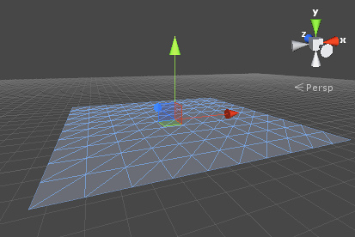 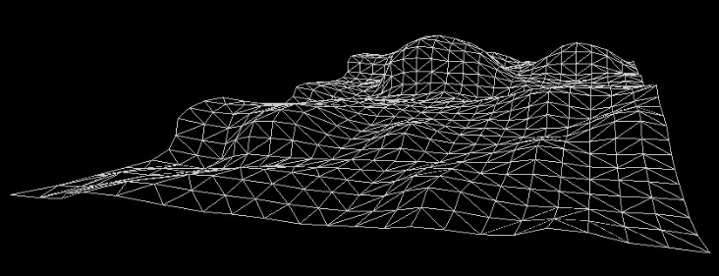

Figure : Plane within the Unity game engine [15] Figure : Generated terrain within Unity [16]

All that is needed to procedurally generate this type of terrain is a method of creating a plane of the desired size and resolution (number of vertices per side), and a function that takes in local vertex coordinates and returns elevation values that can be applied to the plane to create the desired shape. This type of terrain generation can therefore be considered to be two-dimensional in nature; the terrain typically has no volume and the third height dimension is simply a vertical offset applied to its vertices.

### 2.4.1 2D Noise For Terrain

Similarly to textures, terrain requires a smooth distribution of height values to appear realistic and natural, with hills and slopes rather than random high and low points across the surface. This makes noise functions a perfect fit for the second aspect of the terrain generation method described, as the same techniques used for textures can be applied to give the elevation of the terrain at a given point. The local coordinates of a vertex within a plane are taken as the input, and a 2-dimensional noise function provides a real value for the height of that point [2]. The output data can either be rendered directly or stored as a heightmap, which is an image that stores the elevation value of each point of the terrain using one or more colour channels [17].

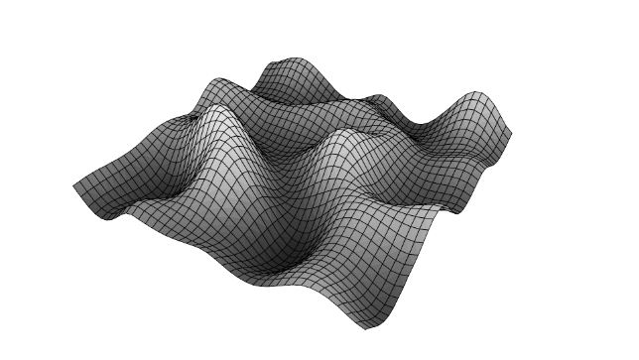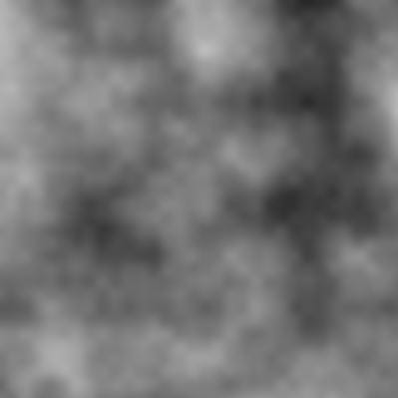

Figure : Visualisation of generated terrain [31]

Figure : Heightmap image generated with Perlin Noise [17]

The chosen noise function is extremely important to the quality of the generated terrain, and noise is often layered several times to produce the desired shape and detail, where each layer has an increased frequency and decreased amplitude to provide finer detail.

### 2.4.2 3D Noise For Planets

This terrain generation process can also be applied to generating planets with continents and mountains, by extending the noise functions used to include a third dimension. The noise functions covered can all be easily scaled up to higher numbers of dimensions, with the process remaining mostly the same other than taking three-dimensional coordinates as the input. These coordinates are usually normalised to a unit sphere before being fed into the noise function, and the output gives the elevation of the given vertex relative to the unit sphere [18]. As mentioned previously, the increased number of dimensions will negatively impact the performance of the noise function used, with the greatest impact being to Perlin Noise [13]. This means that the speed of the chosen algorithm needs to be looked at carefully when implemented, and the final decision of which noise function to use will be affected by the findings.

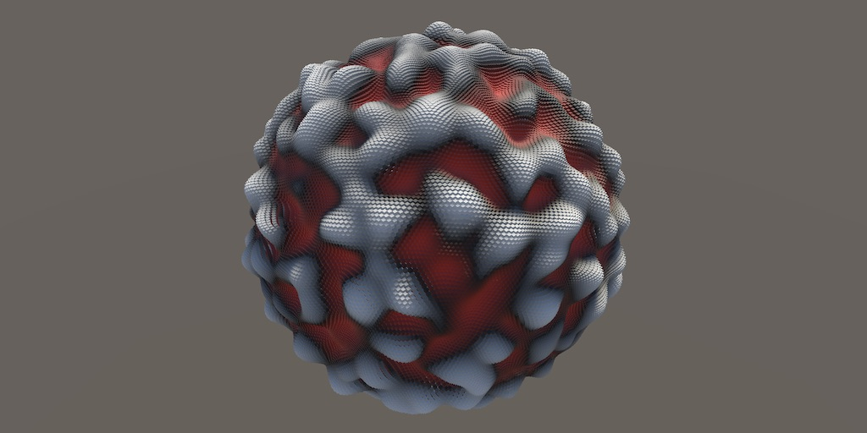

Figure : 3D Simplex Noise applied to a sphere [19]

2D noise can also be used for planet surfaces, by generating elevation data for a plane and then wrapping the plane around a sphere [20]. However this will cause seams where the terrain does not properly line up at the edges of the plane, unless specific measures are taken to match the elevation data at the edges. It is also more complex to implement, rather than simply generating a sphere and using the spatial coordinates of vertices from the sphere at the inputs for the noise function.

## 2.5 Summary and Evaluation of Sources

To summarise, a key aspect of procedural terrain or planet generation is the noise function used to give variety to the surface elevation, in order to create hills, mountains and other details. The noise functions covered can be applied to a plane to generate 2-dimensional terrain with variable height, or to a sphere to generate planets with continents and mountains. Perlin and Simplex Noise produce the highest quality noise but are the most complex algorithms, with Simplex Noise performing better at higher dimensions. This makes Simplex Noise the most suitable for the procedural planet tool as it will use 3-dimensional noise, but Perlin Noise is a good starting point for the implementation as it is slightly simpler and much more studied. The Unity engine even contains an in-built function for 2D Perlin Noise within the *Mathf* class [21], which could possibly be used in an adapted form, or looked at to guide my own implementation of 3D Perlin Noise.

The sources used to inform this background review were chosen due to their relevance, with some covering specific concepts and some relating to the overall project. Different sources were used for each subsection of the background review, with the most useful sources being [5] and [13] as they gave an overview and comparison of several noise functions that was far more helpful than studies or implementations of individual functions. All of the referenced sources related to noise functions are relevant to the project due to noise being a major and crucial part of the planet tool, and each of them helped to build an understanding of the workings of their respective functions.

The most technically valid sources were the published papers covering the theory of the covered algorithms, but the referenced articles and forum posts were equally helpful due to being more digestible and easier to relate to the specific project, despite being far less informative overall. The published papers used presented truthful and reliable information regarding the noise functions and their uses, and were mostly from respected figures within the field such as Ken Perlin [8]. These papers, which formed the basis of the background section, are renowned and highly regarded within the field of noise, and are therefore frequently cited in both current and historical research. The articles and forum posts were used more for implementation-based details of the algorithms. They presented less formal and theoretical information, but far more details on specifics that are relevant to the project, so despite being less reliable or verifiably truthful they still provided a great deal of value.

# **3. Design and Implementation**

## 3.1 Overview of Section

This section details what was done in the project and how, and is structured to follow the order of the development process from start to finish. The methods, tools and processes used will be reviewed, with their strengths and limitations being explored along with a discussion about why each of them was chosen.

## 3.2 Planning

### 3.2.1 Software Development Model

When planning this project it quickly became clear that an iterative approach would be most suitable, so from the beginning there were plans for the inclusion of a cycle where testing would inform development and potentially lead to changes to the design requirements if necessary. An iterative waterfall model was therefore selected as a foundation for the software development process within the project, but the traditional feedback paths of the model were changed slightly. The testing phase was linked to the earlier stages of development with feedback paths, rather than waiting until the maintenance phase to consider iteration. This meant that when testing a version of the code it was possible to revisit earlier stages and make any required changes, which is the purpose behind the original model.

The modification to the feedback paths was simply to fit the model to the structure of this specific project, where maintenance would come after the completion of this dissertation, and iteration was required earlier in development in order to successfully create a sufficient solution. The maintenance stage was still linked to the feedback paths as in the original model, so that after the completion and release of the original tool it will be possible to continually update and improve it based on user feedback. Some other existing versions of the model use bi-directional feedback paths so that every stage can be backtracked from to any other stage, but this level of connection was deemed unnecessary for the project.

The changes made are highlighted in the diagrams that follow, where the updated model is contrasted against the original. The choice of model is justified as the waterfall structure gives a clear outline of the steps that need to be completed, and the modified feedback paths allow the iteration that is crucial to the successful implementation of the tool. The most frequently used feedback path was between testing and implementation, which shows that the changes made to incorporate this were beneficial to the project and enabled smoother development.

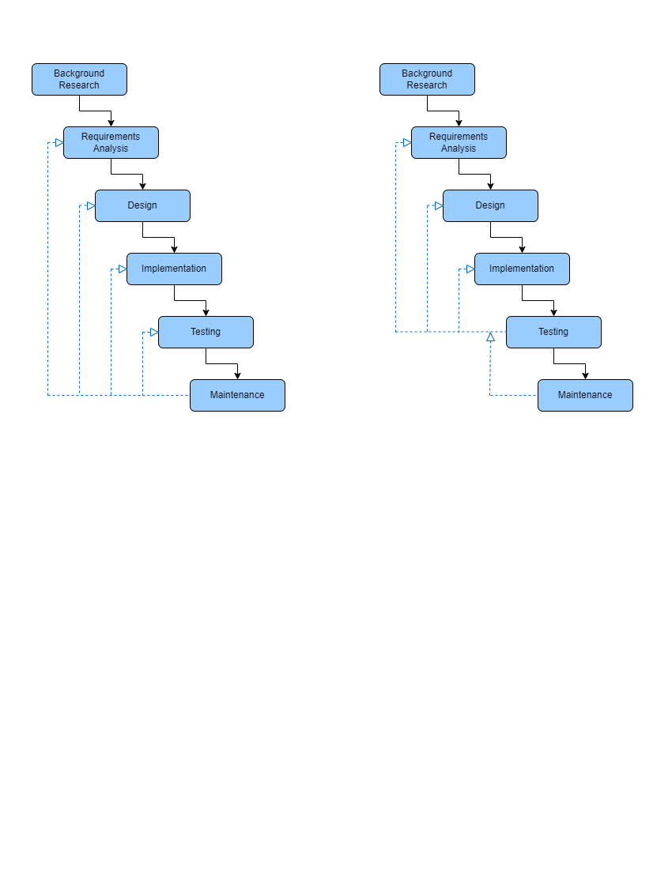

Figure : The standard iterative waterfall model (left) versus the modified model used for the project (right)

### 3.2.2 Tools Used

A key decision was made to use the Unity game engine for the project, as it is an extremely popular game engine particularly with smaller-scale and independent developers, which is the target audience of the tool. It is also the engine with which I am most experienced, which will make development smoother as I have a solid foundation to develop my technical skills from. Unity primarily uses C# scripts, so this is therefore the language which will be used to provide the functionality of the tool. The project will be split into several scripts to make it easier to develop, maintain and use, and the final tool will be released as a Unity package containing all of them upon completion.

## 3.3 Design Requirements

1. **The tool must automatically generate a planet procedurally**
2. **The tool must use noise to create varied terrain on the planet surface**
3. **The tool must include a level of detail system which scales with view distance**
4. **The tool must include a settings menu which can be used to adjust the noise parameters and other variables**
5. **The tool must be able to maintain an average frames per second of above 60 on the testing hardware**

## 3.4 Prototyping of Sphere Generation Techniques

After researching the project area and planning out an approach, the next step was prototyping the most important aspect of the planet tool – the generation of a sphere which can be used as a foundation for a planet to fulfil Design Requirement 1. There are many different methods of generating a spherical mesh, and it was decided that the best course of action was to prototype several of them so that they could be evaluated based on which would be best suited for the needs of the project. All three methods chosen for prototyping are popular for 3D modelling, with the UV Sphere and Icosphere being primitives within the Blender creation suite [22] and the Cube Sphere (or Quad Sphere) also being frequently used within Blender [23].

In order to evaluate the techniques, the requirements for sphere generation within the tool were set out based on the overall design requirements. The notation SGR, for Sphere Generation Requirement, was used for labelling. For each method the advantages and disadvantages will be explained in relation to these requirements, and then which requirements it meets and which it does not will be stated in order to give a clear summary.

### 3.4.1 Sphere Generation Requirements

SGR1 – The output sphere must have a relatively even distribution of vertices across its surface

SGR2 – The generation method will support the implementation of a level of detail system

SGR3 – The generation method must have a low level of complexity for efficient performance

### 3.4.2 UV Spheres

The first sphere generation method prototyped was the UV sphere, where the sphere is made up of rings and segments running horizontally and vertically respectively. Rings run parallel to the equator of the sphere, and segments run vertically between the poles. On the next page the code for generating the UV sphere vertices is included, which is run every game update and contains variables for the number of rings and segments that can be updated in real time to adjust the output sphere. Note that the two poles of the sphere are generated outside of the loops at the first and last positions of the vertex array, and therefore the indexing for the loops starts at 1 to fall between these values. Within the loops, the vertex positions are calculated using two angles labelled ‘phi’ and ‘theta’. The code was adapted from the C++ implementation from [24].



The screenshot below is of the sphere vertices after running the code, using the Gizmos visual debugging feature in Unity to represent each vertex with a small sphere. As shown in the image, UV spheres do not have an even distribution of vertices and there are significantly more around the poles, which would be an issue for this project as the planets would always have higher detail in certain areas regardless of where the player is. They are also extremely difficult to subdivide, as although you can adjust the number of rings and segments you cannot have fine control over the positions and exact number of vertices. For these reasons it was decided that UV spheres would not be suitable for the project, despite being a popular choice for many uses within games such as “bodies, limbs, heads, and pretty much any other organic matter” [25].

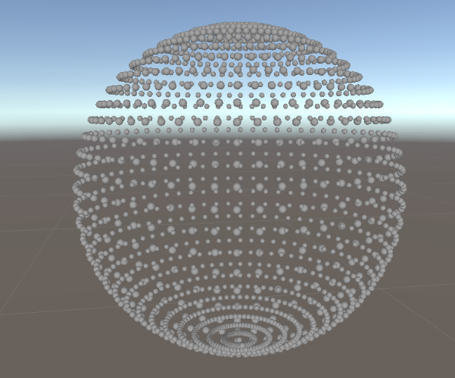

Figure : Generated UV sphere with 30 rings and 60 segments

Requirements met: SGR3

Requirements not met: SGR1, SGR2

### 3.4.3 Cube Spheres

Next a cube sphere generator was implemented, which creates six faces of a cube with a given resolution and normalises the positions of their vertices to make them rounded, therefore making a sphere when the faces are combined. The resolution of the faces can be adjusted meaning you have fine control over the total number of vertices, and because each face is initially square its vertices are well-spaced and it can be easily subdivided. These attributes make cube spheres an ideal choice to use as the foundation of the planets, as detail will be evenly distributed across the planet surface due to the even vertex spacing, and they will be the easiest to work with when implementing a subdivision-based level of detail system.



The above code uses vector directions to create each face and position its vertices within it, calculating the position of each vertex on a unit cube before normalising it. Normalisation moves the vertices so that they are all an equal distance of 1 unit away from the centre of the cube, meaning vertices near the corners are brought inwards and therefore the cube is rounded off. These vertices can be tiled with quads or triangles to create a mesh that appears spherical given a high enough resolution.

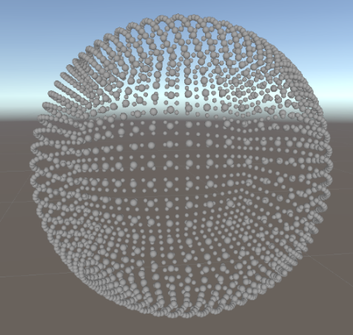

Figure : Generated cube sphere with a resolution of 20

The cube sphere is also referred to as a quad sphere as it is typically tiled with quads, which is possible due to its even vertex spacing that is evident in the screenshot above. This sphere used a resolution of 20, meaning the dimensions of each face are 20 vertices by 20 vertices, totalling 400 per face and 2400 for the whole sphere. Triangles will be used instead of quads to tile the sphere, and the number of triangles required is explained here with an example resolution of 7:

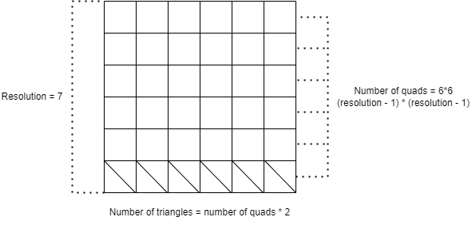

Figure : Relationship between resolution and the number of triangles required per face

This leads to the following equation for the number of triangles per face:



For the generated sphere with a resolution of 20, 722 triangles are needed for each face, and 4332 in total for the sphere. Triangles are represented within Unity as an array of integers that stores the indices for the 3 vertices that make up each triangle. The triangles are not yet implemented for the cube sphere, but this method of creating and storing triangles is shown in the following prototype.

Requirements met: SGR1, SGR2, SGR3

Requirements not met: None

### 3.4.4 Icospheres

An icosphere is created by subdividing an icosahedron until a sufficiently detailed shape is formed to convincingly represent a sphere. You start by creating an icosahedron, which is a 20-sided shape that is in this case made up of 20 evenly sized triangles. For this prototype the triangle generation was implemented as well as the vertices, in order to fully understand the shape being worked with. As described previously, the vertex indices for each triangle are stored in an array, and for clarity they are each on a separate line in the code which is adapted from a C++ implementation found at [26].



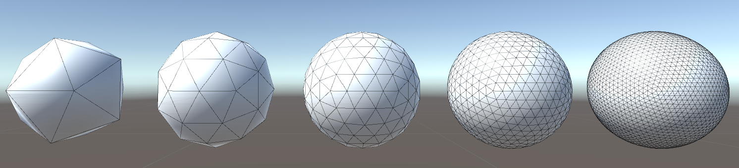An icosahedron requires 12 vertices, the positions of which are calculated using the golden ratio which is stored as ‘phi’. The positions are also normalised so that they are all an equal distance of 1 unit away from the origin, meaning that the resulting sphere after subdivision would have a radius of 1. The icosahedron created with this code is shown in the far left of the image below.

Figure : The generated icosahedron being subdivided to represent a sphere

After generating the icosahedron, the next step is to subdivide it. Each subdivision increases the number of triangles by a factor of 4, as four smaller triangles are formed using the midpoints of the sides of the current, larger ones. The image above shows the results of four subdivisions from left to right, with each increasing the detail of the mesh and making it more closely resemble a true sphere. The image highlights the lack of control over the detail of an icosphere, as the aforementioned increase by a factor of 4 between each version is evident. The detail level is entirely dictated by the number of subdivisions, which must naturally be an integer so no smaller increments can be used to give finer control. This presents a problem for implementing a level of detail system later, as the jumps between detail levels will be huge and extremely noticeable to the player.

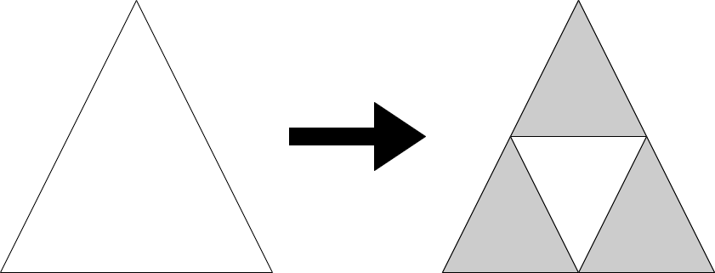

Figure : The triangle subdivision process

Overall this method of generating a sphere proves to be difficult to work with, as it is less intuitive and more complex than the cube sphere method. Subdividing a square requires less computation than a triangle as you can calculate the midpoints more simply, and the process is more suitable to the project with the easy control over the face resolution being a major advantage. The uniform distribution of vertices and therefore detail across the icosphere is perfect for a traversable planet, but the issues that will arise when implementing a level of detail system hold it back.

Requirements met: SGR1

Requirements not met: SGR2, SGR2

### 3.4.5 Conclusions of Prototyping

After implementing and analysing these different sphere generation techniques, the requirements were consulted again in order to decide which method would best enable the inclusion of all of the planned features. The most crucial aspect of the planet sphere generation was maintaining a relatively even distribution of detail across the surface, which was set out in SGR1 and achieved by both the Cube Sphere and Icosphere methods, but not by the UV Sphere.

Because the implementation of a level of detail system was planned as stated in SGR2, the Cube Sphere method was chosen for the tool as this approach would be by far the easiest to work with for this feature. It was the only method to fulfil SGR2, because the other methods would not support subdivision with the fine level of control that is being aimed for. The fact that the foundation for the sphere is a cube means that each of the six cube faces can be easily subdivided using a quadtree system, as described in section 3.4.3. This decision seemed likely during the initial analysis of the Cube Sphere as it appeared to fulfilled all of the needs of the project while the other methods did not, but the time was still taken to prototype and review all three techniques against the SGR requirements to ensure that the correct decision was made. The Cube Sphere method successfully met all three requirements, making it the ideal choice for the tool especially when compared to the other two methods that each only fulfilled one.

The decision to prototype the sphere generation methods before making any conclusions proved to be hugely beneficial, as existing implementations were still analysed to gain an understanding of how they work, but this understanding was then developed further by putting it to practical use. The prototyping made the advantages and disadvantages of each method abundantly clear, as it was much easier to contrast them when their respective pieces of code could be worked with directly to adjust the visual output in real time. The Icosphere method was found to be the most complex to implement and work with compared to the other two, which also factored into the decision but would not have been known if each of them had not been prototyped.

## 3.5 Implementation Of Planet Tool

Now that the sphere generation technique had been chosen, this work could be expanded upon by beginning to implement the other features. This section will detail each of them, explaining why they are important and what methods were used to develop them.

### 3.5.1 Noise Function and Layers

Based on the background research done, the decision was made to implement 3D Perlin Noise for the tool as a starting point to fulfil Design Requirement 2, and then use a library function for a Simplex Noise alternative due to its additional complexity but faster performance. The Unity Mathf library includes a 2D Perlin Noise function, and during research a relatively simple 3D implementation was discovered that utilised this function [27]. It was therefore decided to use this implementation within the tool, and no issues with artefacts or symmetry in the noise were noticed. The code from this Unity Answers forum post is shown on the following page.

The y and z coordinates are offset as Perlin Noise is mirrored around zero, so this helps to prevent symmetry in the noise. 2D Perlin Noise is sampled for each of the 6 pairs of coordinates, with the results being transformed by Pi and Sin functions.



Next an implementation for Simplex Noise was introduced, and a C# implementation of OpenSimplex Noise was used from GitHub user ‘digitalshadow’ [28]. This algorithm drastically improves performance, as will be discussed in the ‘Results and Evaluation’ section.

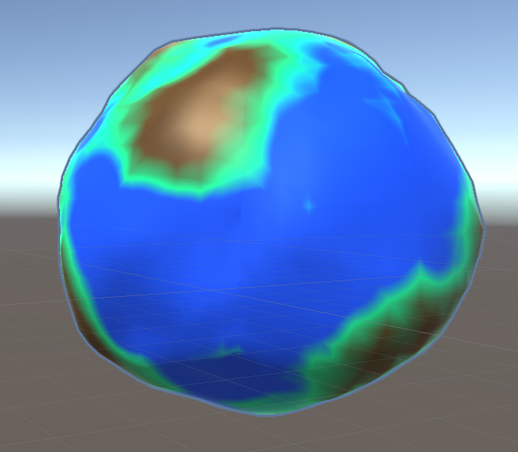

Figure : Planet generated with Simplex Noise

To utilise either of these noise functions, an *EvaluateNoise* function was created which takes in a vertex position on a unit sphere, and transforms its coordinates based on the noise settings covered in section 3.5.4 before using this new position to sample from the noise function. The process is repeated for each noise layer, with the sampling position being modified each layer based on the settings. The code for this function is shown on the following page, with the Perlin Noise line commented out.



The roughness setting acts as a multiplier for the frequency each layer, as does the persistence setting for the amplitude. This causes each layer to sample at a higher frequency for finer details, and have a smaller amplitude so it causes smaller changes in elevation. The maximum is taken between 0 and the noise value minus the subtraction value, which brings all values inwards towards the centre of the planet before bottoming out at 0 to create flat oceans. The final noise value for the vertex is multiplied by the noise strength setting and returned.

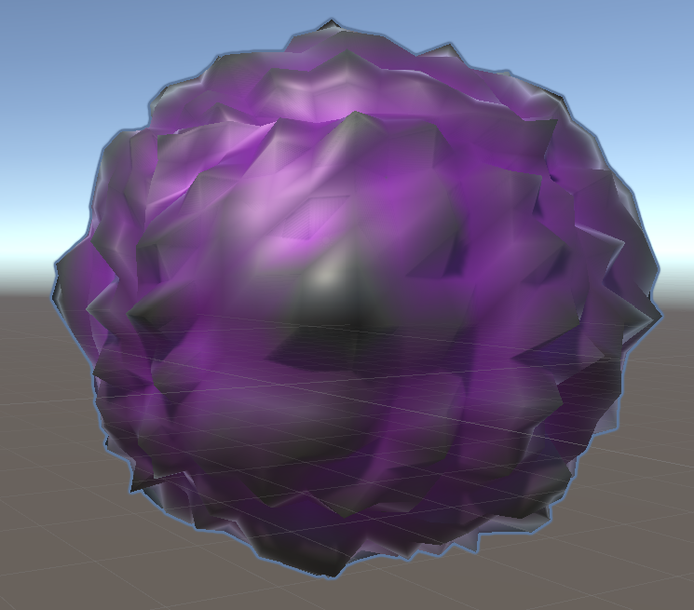 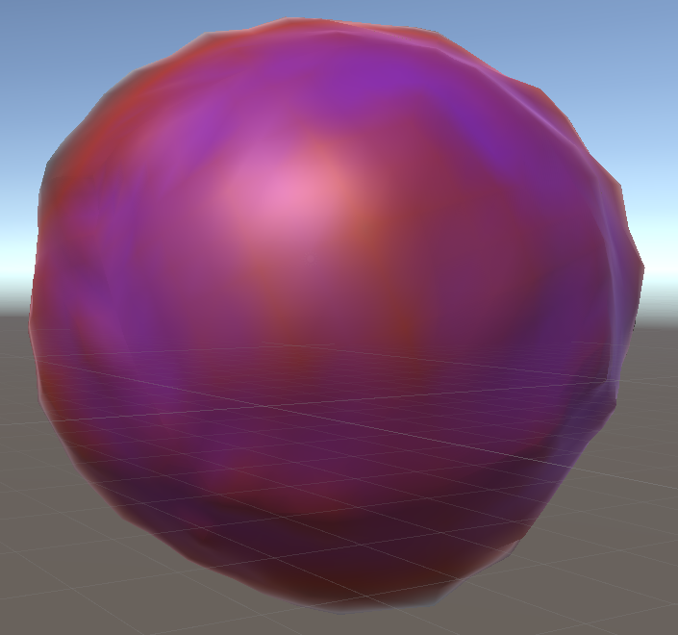

Figure : Planet with high roughness Figure : Planet with low roughness

### 3.5.2 Level of Detail System

The goal of the project is to create planets which can be used within a playable game environment, so it is important that they can be rendered in sufficiently high detail when a player is close to the surface. In order to achieve this high fidelity up close without compromising performance, the decision was made to implement a level of detail system as stated in Design Requirement 3. This means that when the planet is viewed from far away it can be rendered in lower quality, and as the player moves closer the detail level will increase up to a maximum, with the number of vertices and triangles in the mesh increasing accordingly. There are 10 distinct detail levels, indexed 0 to 9, which each signifies an increase in the number of vertices and triangles by a factor of 4. This is done using a quadtree system, so this subsection will first explain how these work before explaining the implementation.

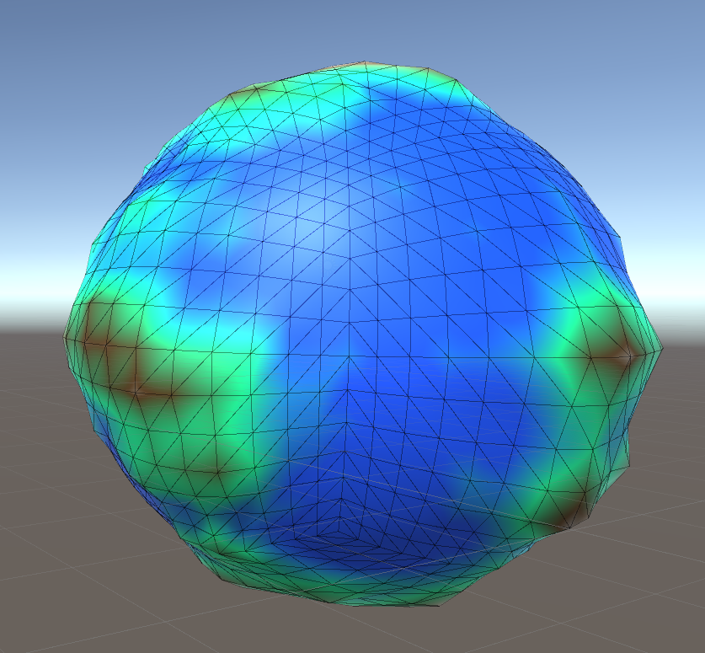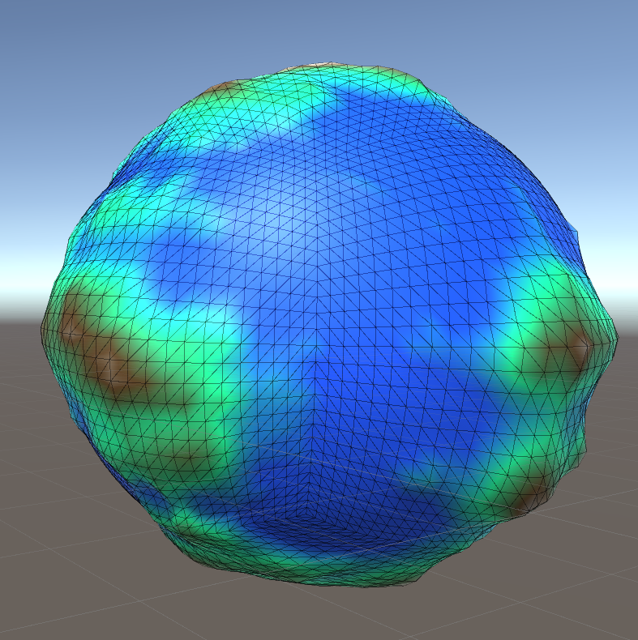 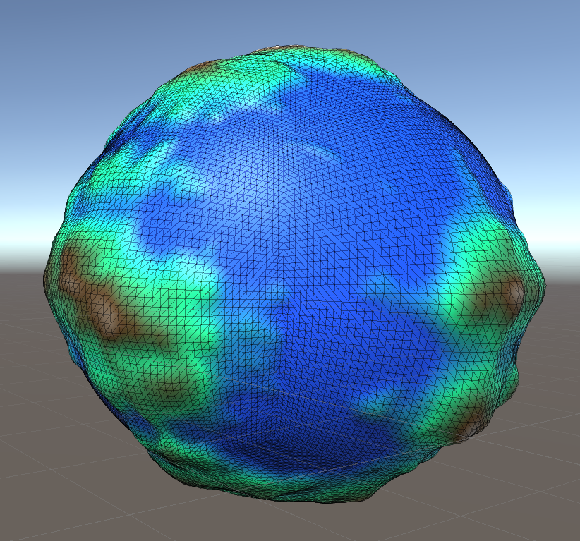 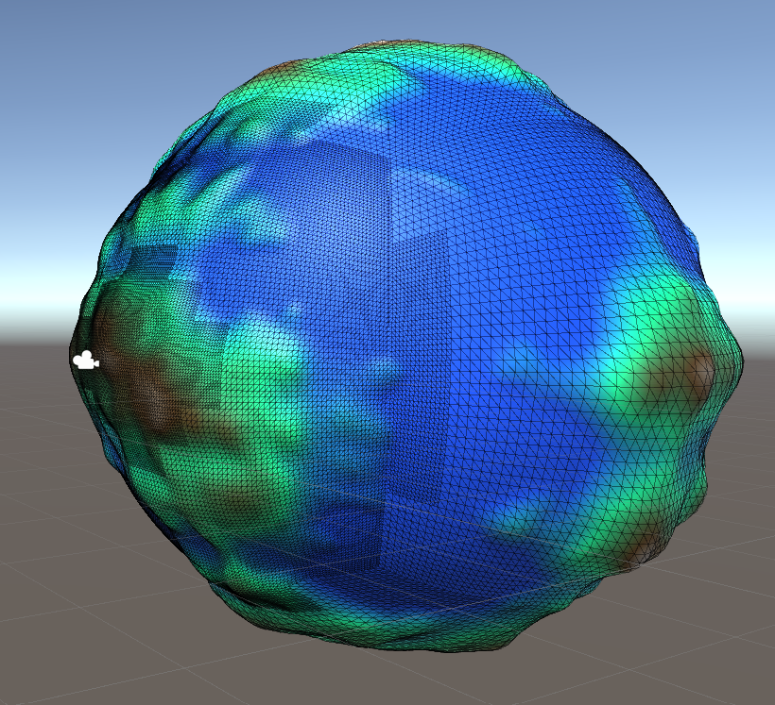

Figure : Generated planet with player camera at distances of 70, 30, 10 and 2 units from surface

A quadtree is a tree data structure where each non-leaf node has exactly four children, meaning every node in the tree has either four children or none. Quadtrees can therefore be used to partition a two-dimensional space by recursively subdividing it into four quadrants, where each quadrant represents a node in the underlying tree structure [29]. Nodes can be defined as having a maximum capacity, and so if a quadtree is applied to a 2D area of space containing data points such as objects, a node will be subdivided into 4 if its region contains more data points than the maximum capacity.

For the purpose of the level of detail system, the number of subdivisions will not depend on a maximum node capacity, but rather on the distance of the player from a section of the planet. As mentioned previously the core planet shape is being generated using a Cube Sphere method, so each of the 6 faces of the cube can act as a quadtree that is broken up into quadrants, or chunks as named here. Each of the 10 detail levels has a maximum distance associated with it, and if the player is within that distance of a chunk then it is subdivided into 4 children and the detail level of the children is increased by 1. The subdivision function works recursively, so each newly generated child chunk has the function called upon it.

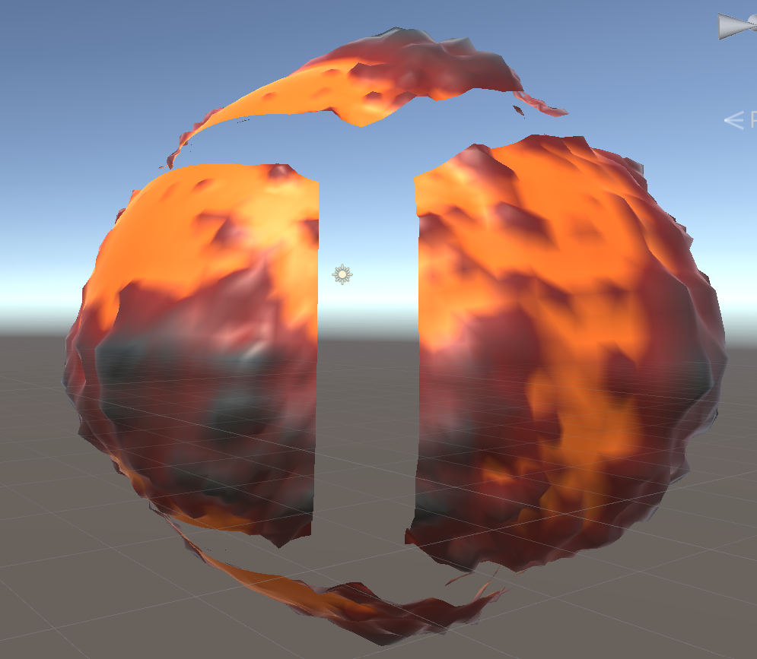

Figure : Generated planet with its 6 Cube Sphere faces spaced out

This system not only allows the detail of the overall planet to scale based on the distance the player is from it, but also means that different sections of the planet surface can have different detail levels. This means that a player landing on the planet will be met with a highly detailed mesh around them, while further away areas that are less visible will be rendered with less vertices and triangles to improve performance. This dynamic approach drastically reduces the computational expense of providing a high-quality experience to the player, compared to rendering the entire planet at the same detail level.

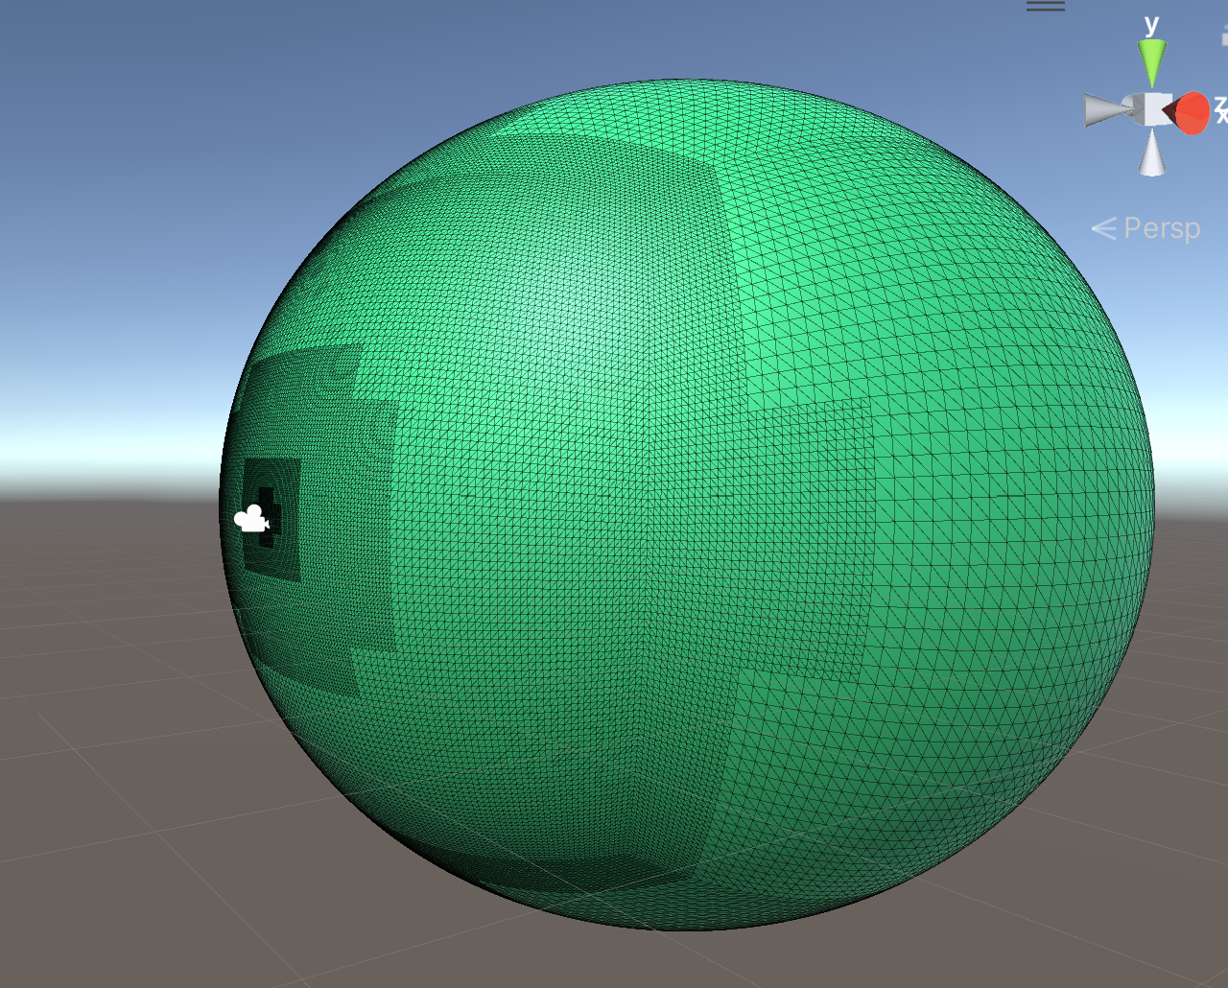

Figure : Level of detail system shown on a sphere

This was implemented by creating a chunk class which stores its detail level, as well as its parent and child chunks among other attributes. To build the quadtree for each face of the planet, a chunk with no parent is created to act as the root of the tree, and then the following function is called upon it to recursively find all leaf nodes in the tree:



This checks if the chunk is of the maximum detail level (index value of 9) or if the player is further away from the chunk than the maximum distance of its detail level, adding the chunk to the list of leaf chunks in either case. Leaf chunks are the only chunks which need to be rendered, as they are at the correct detail level and should not be subdivided. If neither of the statements are true, then the chunk is not a leaf node within the tree, and it is subdivided into four child chunks with the *SubdivideChunk* function. Each set of 4 new children are sized and positioned so that together they form the same section of the face as their parent chunk just in four times higher detail, as each chunk contains the same number of vertices and triangles no matter its size. The function is then recursively called on each of the 4 children, and so the process is repeated until all leaf chunks are found and the tree is complete. The vertices and triangles of the leaf nodes can then be calculated and added to lists containing all data for the face. These calculations will be shown and explained in the next section, where they were extended to fix a lighting issue that arose.

### 3.5.3 Overlapping Triangles

After implementing the quadtree level of detail system and testing it, issues with the lighting were noticed where there was a visible seam between chunks within each face of the planet. This was because of an issue with normals, which are vectors perpendicular to surfaces that are used for lighting. The normal calculations only include triangles within the current chunk, so along the boundaries the neighbouring triangles from the next chunk would not be included in the calculation. This led to each side of the boundary having different normals that did not match up, causing the noticeable lines despite there being no discrepancies in terrain elevation. In order to fix this and have a seamless transition between chunks, the normal calculations for each chunk would need to include extra triangles from the adjacent chunks so that they would produce the desired normals.

Several approaches to solve this problem were considered, but after some research a conclusion was reached that the simplest way would be to increase the size of each chunk by 2 on each axis, providing a border of 1 vertex on each edge to produce triangles that would overlap with neighbouring chunks. The correct normals could be calculated using this larger mesh data, before removing the border triangles from the mesh. The inclusion of the overlap triangles in the calculations means that two adjacent chunks will have the same normals along the boundary, so there is a seamless transition between them. Each chunk’s non-border triangles were added to a separate array, and then this data was handled in the same way as for the larger triangle arrays so that after the normal calculations the entire terrain face’s triangle array could simply be replaced with the non-border array.

The code above shows the use of the smaller and larger triangle arrays within each face of a planet, with the larger used for normal calculations before being swapped for the smaller, non-border array for rendering. The following page shows the calculation of the vertices and triangles in a chunk, which was based upon code and principles from [30].



This function works by defining an overlap resolution that is 2 larger than the true resolution of a chunk, as well as a smaller resolution which is equal to the true resolution. The overlap resolution is used for the size of the vertices and triangles arrays, while the smaller resolution is used for the array of non-border triangles. All three arrays have their own index. Each vertex is looped through, calculating its position on a unit cube before normalising it to give its position on a unit sphere. The elevation is calculated using a noise function, and the vertex is added to the array with its final position.

The triangles are also generated in the loop if the current vertex is not on the right or top line of the chunk, with the triangle offset being used so that the triangles of multiple chunks can be stored together without indexing issues. The triangle array simply stores indices to the vertex array, meaning if there was no offset the triangles from all chunks would eventually be rendered using vertices from the first chunk in the face, so all of the triangles would overlap. The image below shows the positions of other vertices in each triangle relative to the current vertex *i*, to explain the vertex indices entered into the triangle arrays in the code. To move right one column you add 1 to the vertex index, and to move up one row you add the resolution, due to the way the loops work.

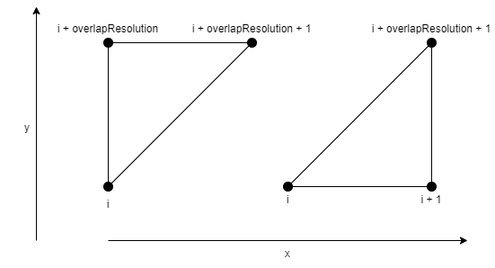

Figure : Diagram showing the relationship between the vertex indices in each triangle

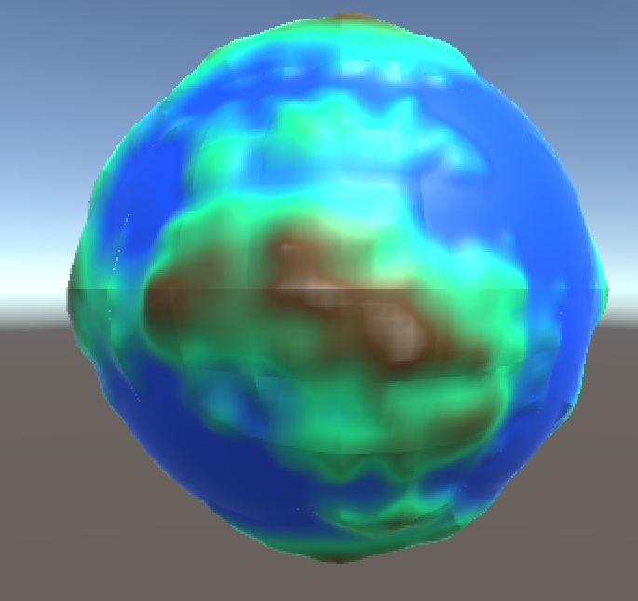 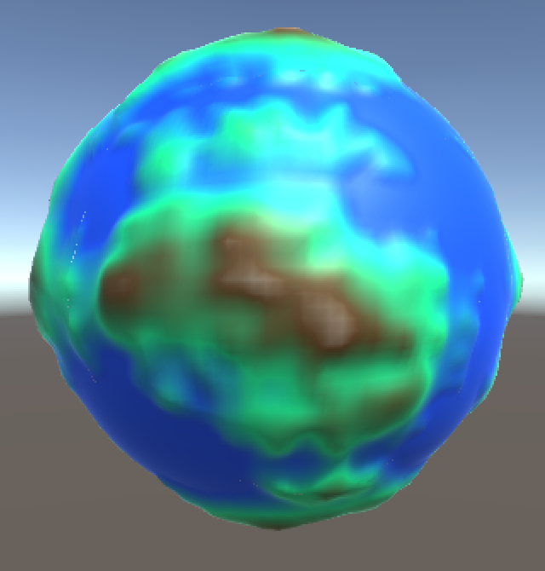

Figure : The same generated planet, before and after the overlapping triangles fix

### 3.5.4 Planet Settings

A key aspect of the tool’s utility is the ability for users to be able to edit the planets to create a result that suits their needs. It was therefore decided to provide a range of settings in the main Planet script that show up in the inspector tab within Unity, in order to fulfil Design Requirement 4. The tool is intended to be used by game developers rather than players, so there is no need for an in-game settings menu and this approach was much more appropriate. The implementation of inspector settings within a C# script is very simple, and all that was required was to include serialized variables in the Planet script which were used within the calculations for noise, chunk creation and other functions. The range attribute was used to provide a slider for each variable, with appropriate upper and lower limits.

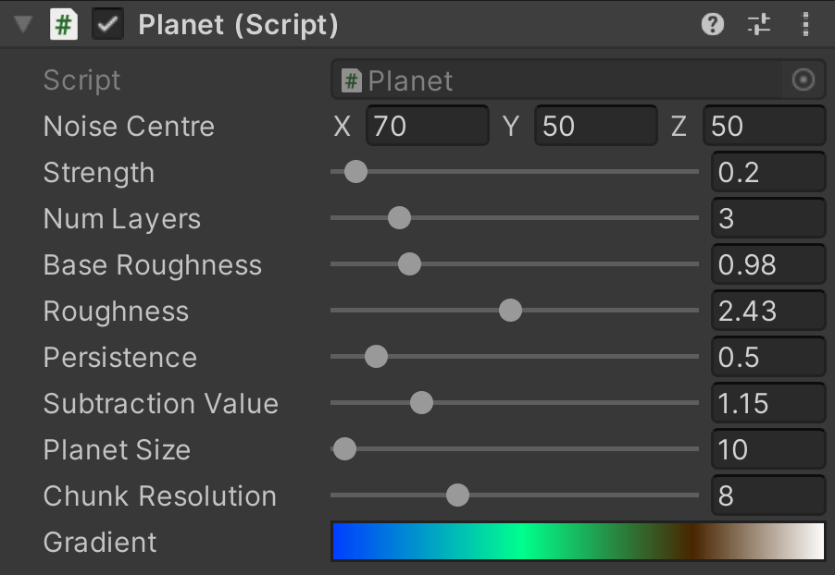

Figure : Screenshot of Planet script settings in inspector tab

These settings can be set for each planet before running the script and generating them, but can also be adjusted in real time while the tool is being used. A simple demonstration scene was created that shows the planet on an empty skybox background, with a navigable camera that can be controlled to show the planet as it will be seen by players in game. This scene also highlights the level of detail system described in section 3.5.2 which is shown in action, changing the number of chunks based on the distance of the player camera from the planet in the scene. The purpose of the demonstration scene is mainly to give developers an opportunity to tune their planet settings with real-time updates so that they can achieve their desired visuals, but also to build an understanding of how the additional features such as the LOD system work so that they can incorporate them into their game.

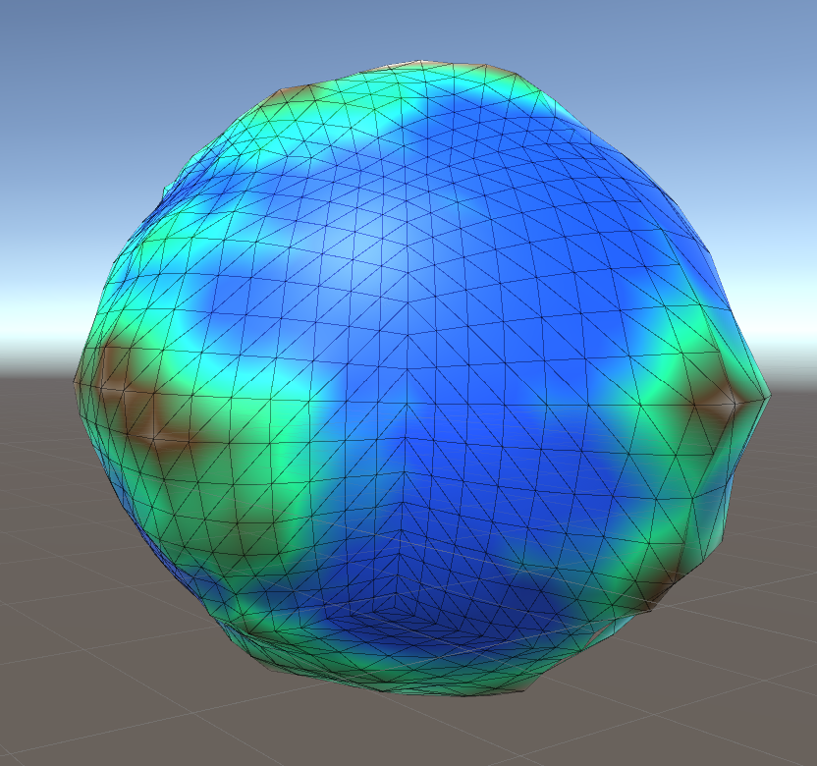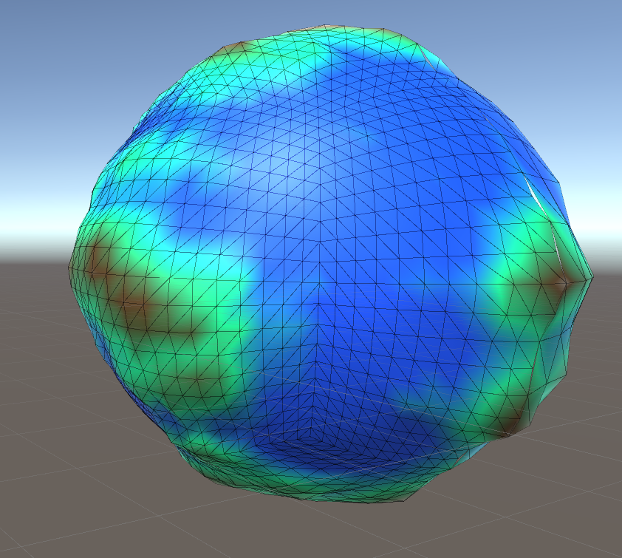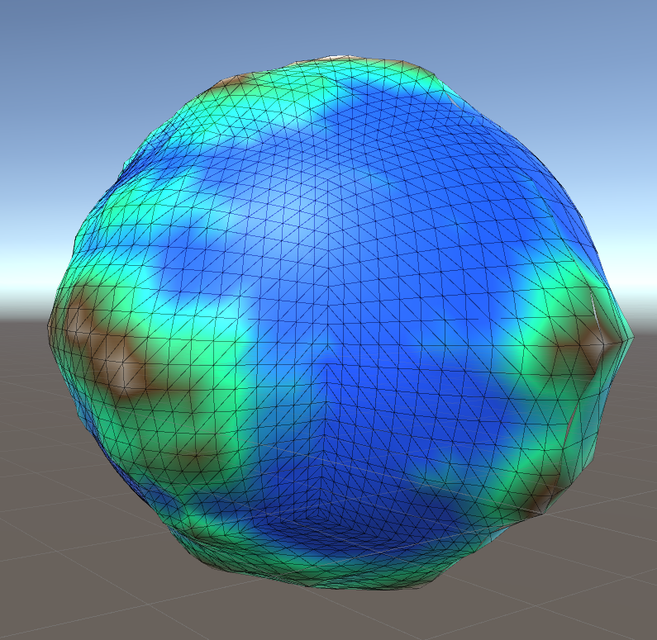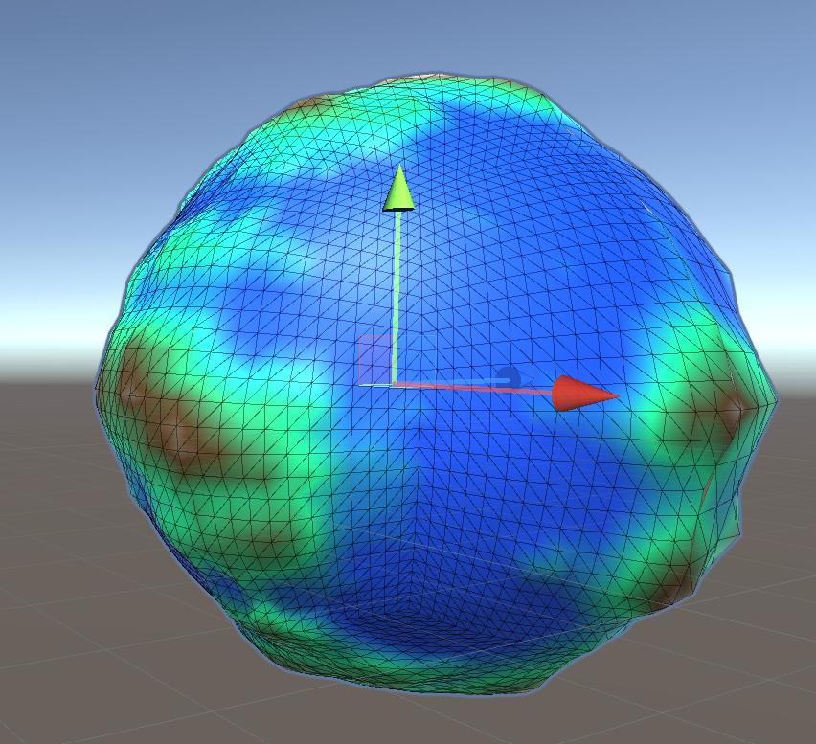

Figure : Generated planet shown with increasing chunk resolution from 5 to 8

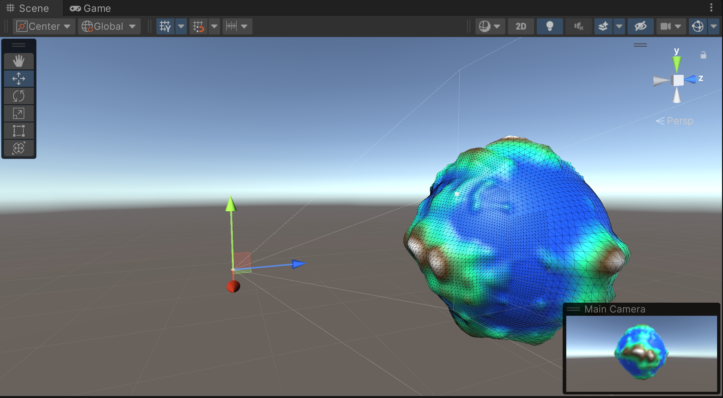

Figure : Screenshot of demonstration scene with navigable camera

For the planet surface colouring, a gradient was used which would be applied to the planet material with colours varying based on the terrain elevation. This was so that the inspector settings could include the gradient which can be easily adjusted, and gives fine control over the terrain colour by allowing the user to edit, add and remove colours at any elevation level. The built-in gradient editor serves this purpose well, so there was no need to implement this separately when it could be used instead. Users can even save gradient presets, so that colour settings can be reused across multiple planets or used as a starting point for a new colour palette.

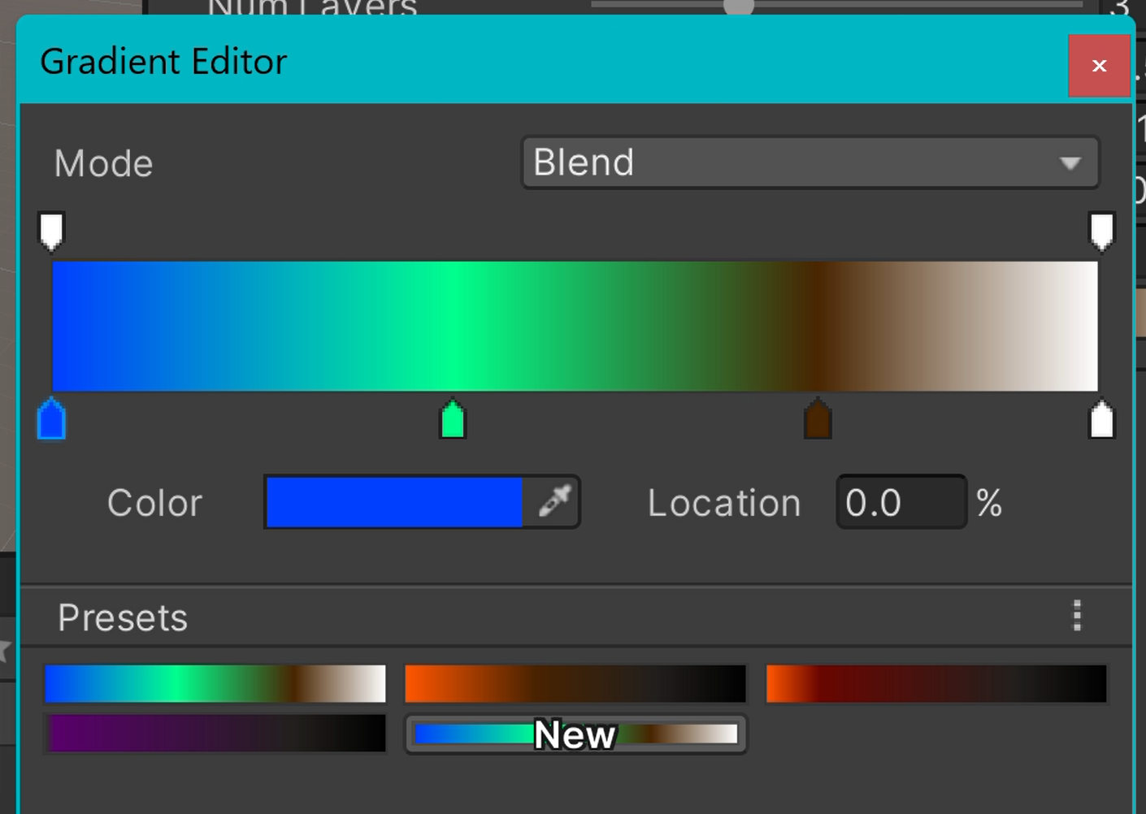

Figure : Screenshot of Unity gradient editor with example planet colour data

### 3.5.5 Optimisations and Improvements

In order to improve the performance of my tool and fulfil Design Requirement 5, optimisations and improvements were made to the code. Naturally many small improvements were made during development, but the more significant changed will be noted here. The most impactful change was reducing how often the planet was updated. This was originally done every frame within the *update* function, but was reduced to a fixed rate of five times per second. The frequency of updates was further changed by removing the fixed update rate entirely, and instead only updating if a change was made. Changes in either the inspector settings or the player position needed to trigger the updates, so the inbuilt *OnValidate* function was used for inspector settings changes, and a coroutine was used to check if the player position had changed 5 times per second. The code for both is shown below. This optimisation will be referred to as ‘Stationary Optimisation Change’ during testing.



Another optimisation made was to the generation of triangles. Initially triangles were generated in their own loop, and once the overlap triangles were implemented they were generated in a third loop. To optimise this, the triangle generation was moved into the vertex loop, and modified to create two triangles for the current vertex if it is not on the right or top line of a chunk. While there are now several nested loops and statements, this reduction in the number of sequential loops greatly improved performance.



Another simple way to improve performance is to reduce the number of detail levels, as for most use cases 10 levels are not necessary. The performance greatly improves when this number is reduced, especially when the camera is close enough to reach the highest possible detail level. The same applies to the planet update rate, which is set at every 0.2 seconds currently. The chunk resolution also affects performance, as do other inspector settings such as the number of noise layers. The impact of these variables will be tested in the next section.

## 3.6 Testing Methodology

### 3.6.1 Benchmark Script

In order to test the tool effectively to verify the fulfilment of Design Requirement 5, a benchmark script was created that could be executed within the demonstration scene. The script is attached to the player camera, and contains two benchmarks – a stationary benchmark, and a movement benchmark where the player camera is brought towards the planet at a constant speed, after an initial wait duration. The script has several options that can be edited within the Unity editor, to make testing more efficient. The duration of the benchmark and distance of the player camera from the planet can be set, as well as the wait duration and speed for movement benchmarks. The benchmark script code is contained within Appendix A.

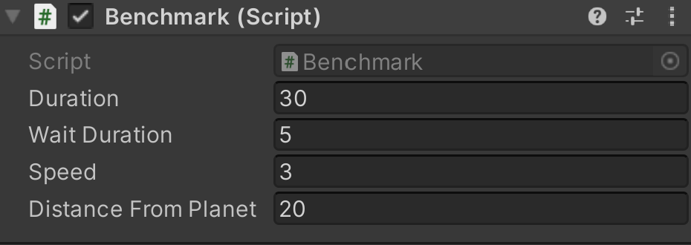

Figure : Benchmark script settings

The stationary benchmark simply positions the player camera at the set distance from the planet, and records the frame data for the given duration. The movement benchmark positions the player camera at the set distance, waits in position for the length of the wait duration, and then moves the player camera towards the planet at the given speed, with frame data being recorded throughout.

Each frame a frame counter is incremented by 1, and a timer is increased by the frame time of the previous frame in seconds using the inbuilt *Time.deltaTime* value within Unity. This data is used to calculate an average frames per second (FPS) metric for the benchmark by dividing the number of frames by the total frame time. This is the most important metric for the tests as a high enough frame rate must be maintained to ensure the scene is playable, with 60 FPS or above on average being considered as the minimum for a modern PC game. If a 60 FPS average cannot be achieved within the demonstration scene benchmark, then the tool will not be suitable for using in games as its performance will prevent the game from being considered playable by many players. The results of testing the tool are therefore critical to the success of this project, and they will be presented and evaluated in the following section.

The minimum and maximum FPS reached during the benchmark are also recorded, by tracking the highest and lowest frame times achieved and calculating the inverse of those values. These values are not as useful as the extreme values will always fluctuate significantly, but they do give some insight into the best and worst levels of performance achieved during the benchmark. All three metrics are outputted through a message that is logged to the Unity console.

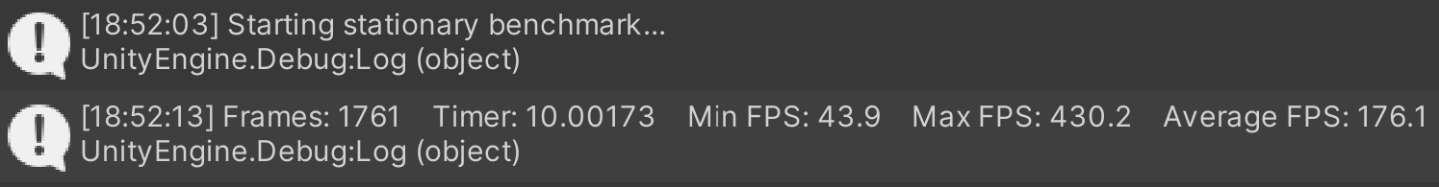

Figure : Screenshot of the Unity console output after performing a benchmark

### 3.6.2 Hardware

The testing will be performed on a Dell XPS 15 9500 laptop running Windows 11, with an Intel i7-10750H 6 core CPU clocked at 2.60GHz, 16GB of RAM and an NVIDIA GeForce GTX 1650 Ti mobile GPU. This is a reasonably high-spec laptop but it is naturally limited by its form factor and thermal performance, which are the main reasons laptops generally contain less powerful hardware and perform much worse than desktop computers. If the tool can achieve a satisfactory frame rate on this device then it can be expected to perform even better on desktop gaming hardware or modern games consoles, which is the target platform for the tool to be used in development for.

### 3.6.3 Testing Strategy

Testing will be broken down into three phases – Stationary Benchmarks, Movement Benchmarks, and Noise Function Comparison. Each phase will test different variables, beginning with phase 1 which will assess the impact of the Stationary Optimisation Change (SOC) described in section 3.5.5 by comparing the frame rates of the tool with and without the change at various distances and chunk resolutions. Phase 2 will focus on the other variables, looking at whether there is a performance impact from the other planet settings as well as trying different benchmark settings so that performance can be assessed under different conditions. Phase 3 will look at the difference in performance when using Perlin or Simplex Noise for the planets, and provide data under conditions similar to the intended real-world use of the tool. Observations in all phases will be largely focused on the average FPS metric, for the reasons discussed previously.

### 3.6.4 Default Settings

Each testing phase will focus on the impact of specific variables, and so a set of default values for all parameters is needed. The default values for each setting are listed below, and any changes from these values will be noted for each test. The values for the planet settings were chosen as they represent the tool well by producing a visually appealing example planet.

As the purpose of the testing is to assess the impact of the settings and variables, Perlin Noise was used for the majority of the testing and is therefore the default selection here rather than Simplex Noise. This is because its significantly slower overall performance will better highlight the differences between different settings values, so that they can be contrasted more easily. The choice of noise function does not affect how any of the settings work, and testing will also be done to show the difference in performance of the tool between using Perlin and Simplex Noise.

Planet Settings

* Noise centre – (70, 50, 50)
* Strength – 0.2
* Number of Layers - 3
* Base Roughness – 1.0
* Roughness – 2.5
* Persistence – 0.5
* Subtraction Value – 1.15
* Planet Size – 10
* Chunk Resolution – 8

Benchmark Script Settings

* Duration – 30
* Wait Duration – 5
* Speed – 3
* Distance From Planet – 80

Other Features of Note

* Perlin Noise used
* 10 detail levels for the LOD system, with maximum distances of infinity, 5, 2.5, 1, 0.5, 0.2, 0.1, 0.05, 0.02, 0.01 units from lowest to highest (these are multiplied by the planet size, 10 here)
* Stationary Optimisation Change (SOC) enabled by default
* Planet update (or camera position check with SOC enabled) every 0.2 seconds

Figure : Screenshot of planet generated with default settings

# **4. Results and Evaluation**

This section will present the outputs and results of the project, describing them thoroughly and using them as evidence to form an evaluation. The following material will be covered:

* Format and presentation of the output tool (Design Requirements 1 to 4)
* Presentation and description of testing results (Design Requirement 5)
* Evaluation of results and overall approach

## 4.1 Format of Tool

The primary output of the project is the planet tool, which will be delivered as a Unity package for developers to use in their games and project. The tool output demonstrates the fulfilment of Design Requirements 1 to 4 via the features detailed in the ‘Design and Implementation’ section. The package consists of six C# scripts, the planet shader and material, and the demonstration scene. Each of the scripts are well-documented, and structured in a clear and concise manner. This makes it extremely easy to start using, and to understand the workings behind each aspect of the code. The package is structured in the following way, according to Unity’s provided guidelines for custom packages:



The *PlayerMovement* script provides a simple character controller for the demonstration scene, the *Benchmark* script is used for testing and was discussed in section 3.6.1, and the other scripts contribute towards generating and rendering the planets. The tool is used primarily through the simple inspector settings menu, which successfully serves its purpose of allowing developers to make changes to planets in real time within the engine. Each of the settings is labelled clearly, and further explanation is provided within the code comments if required. All of the settings are contained within the Planet script, for ease of access and use.

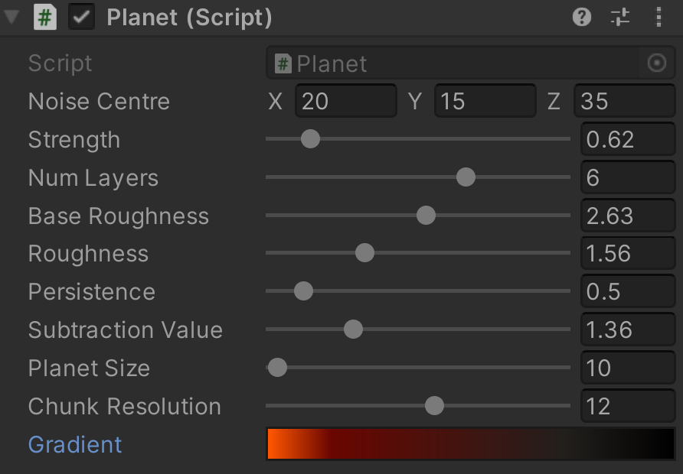

Figure : Screenshot of Planet script settings in inspector tab

## 4.2 Results

### 4.2.1 Stationary Benchmarks

The stationary benchmark was used to test the performance of the tool with the Stationary Optimisation Change (SOC) disabled and enabled at four distances: 80, 40, 20 and 10 units away from the planet centre. For each distance, six chunk resolutions were tested so that the results can be used to evaluate the impact of both the optimisation change and the chunk resolution parameter on performance. All other settings remained default. The following screenshots show the testing tables from Appendix B:

Distance: 80 Units

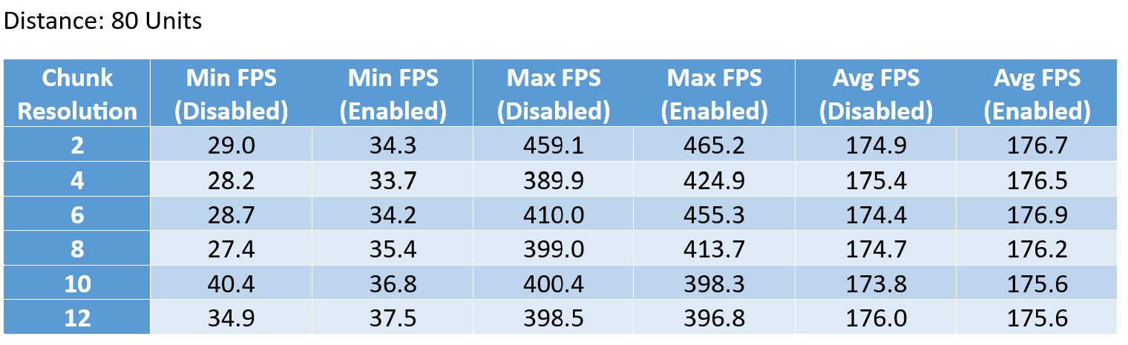

Figure : Screenshot of stationary benchmark results at 80 units distance

These results show that at a distance of 80 units there is negligible impact from increasing the chunk resolution. This is because the planet is being rendered at the lowest detail level at this distance, meaning there is only four chunks making up each face so even with a high chunk resolution there is not many vertices and triangles overall. Because of the smooth performance even at high chunk resolutions, the SOC has no noticeable impact. The results also show the huge variation in minimum and maximum FPS values which is present in all of the tests.

Distance: 40 Units

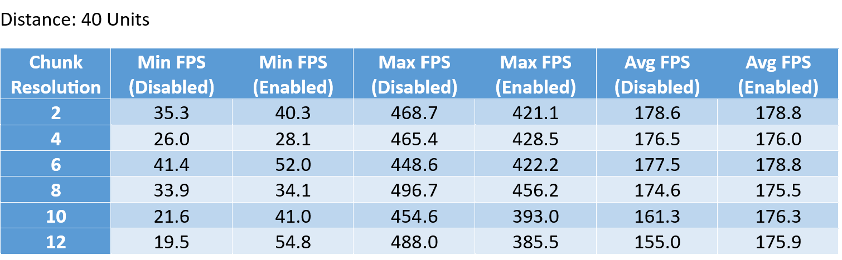

Figure : Screenshot of stationary benchmark results at 40 units distance

At 40 units away, a drop-off in average FPS at higher chunk resolutions begins to surface with the SOC disabled. However the SOC rectifies this decline, keeping the average consistently around what appears to be the baseline for the benchmark on this laptop. This is because the planet face quadtrees are only generated once, as the camera remains stationary and no inspector settings are changed, so the planet is not updated and no mesh data computation is being done.

Distance: 20 Units

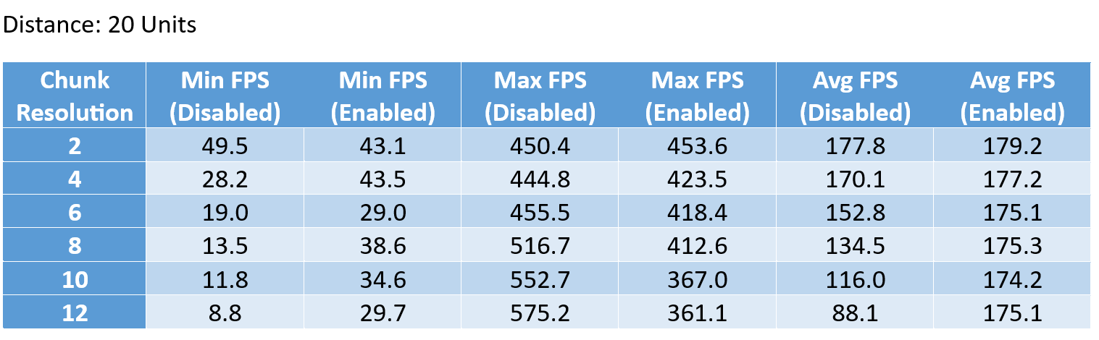

Figure : Screenshot of stationary benchmark results at 20 units distance

The performance decline with SOC disabled is even more evident at 20 units away, and the benefits of enabling SOC when the camera is stationary become apparent. There is no disadvantage to enabling it, as it simply prevents the unnecessary repetition of planet generation when no variables change. This greatly improves performance for applications where the planet will be viewed from a constant distance and its noise settings will not be changed, such as for background planets in a space station scene.

Distance: 10 Units

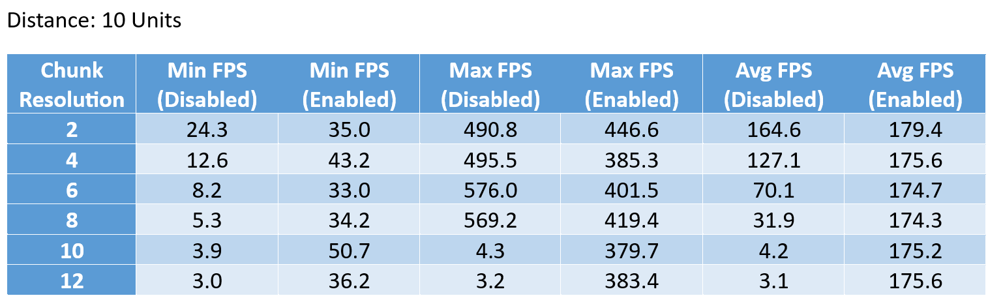

Figure : Screenshot of stationary benchmark results at 10 units distance

10 units away is where the average FPS first falls below the 60 FPS threshold, with a chunk resolution of 8 or higher preventing the scene from meeting the set standard with SOC disabled. The planet is of the default size of 10 for the tests, so here the camera is on the planet surface. This means that for the planet to be viewed up close, SOC must be enabled to maintain a playable frame rate when using Perlin Noise. However SOC only provides benefit when the player camera remains stationary, so if the use of the tool requires landing on the generated planets and moving around then the planet updates will need to be made less frequent.

The following charts summarise the findings from this phase of testing, showing the average FPS achieved at each distance and chunk resolution. They highlight the impact of the SOC, which brings the results of each of the tests extremely close together, with the differences likely being due to external factors such as thermal bottlenecking. With the SOC disabled, there is a steep falloff in performance at higher chunk resolutions. A resolution of 6 can be considered a good middle ground for Perlin Noise planets, where the average FPS is still above the 60 FPS threshold and the planet has a reasonably high detail level.

Figure : Chart showing average FPS in stationary benchmark, with SOC disabled

Figure : Chart showing average FPS in stationary benchmark, with SOC enabled

### 4.2.2 Movement Benchmarks

For phase 2 of testing, the movement benchmark was used to test the other variables in the planet and benchmark scripts. The SOC will have limited effect here as it will only improve performance for the wait duration, but it is enabled regardless. The full tests can be found in Appendix B, but the key results will be presented and analysed here using charts.

Firstly, to test whether there was any performance impact from changing the other planet script settings, a series of configurations were tested. The first was the default configuration, which is the same as was used for the stationary benchmark testing. The following configurations were also tested with the same chunk resolution increments as in phase 1:

Baseline ‘Middle Ground’ Settings

* Strength – 1
* Base Roughness – 2
* Roughness – 1
* Persistence – 1
* Subtraction Value – 1

Maximum Value Settings

* Strength – 5
* Base Roughness – 5
* Roughness – 5
* Persistence – 5
* Subtraction Value – 5

Minimum Value Settings

* Strength – 0
* Base Roughness – 0
* Roughness – 0
* Persistence – 0
* Subtraction Value – 0

Note that ‘Noise Centre’, ‘Number of Layers’ and ‘Planet Size’ are not mentioned as they were left at values of (0, 0, 0), 3 and 10 for all configurations. ‘Number of Layers’ will be looked at separately in the next set of tests as it is expected to have a significant effect on performance, ‘Noise Centre’ does not need to be changed, and changing the ‘Planet Size’ will interfere with the way the benchmark works.

Figure : Chart showing average FPS in movement benchmark, with different planet settings configurations

The above chart shows the performance of the four configurations, which each show a steady drop-off with higher chunk resolutions. This is logical, as the more detailed planets require more processing to generate and render. The primary takeaway from this chart is the lack of performance impact from changing the other planet settings though, as all four configurations show extremely similar performance with average FPS values within a margin of error of each other.

Next the ‘Number of Layers’ setting was tested, to see how much the inclusion of additional layers of noise would impact performance. The chunk resolution was kept constant at the default value of 8 initially, and then the tests were repeated with a resolution of 2 and then 12 to see if there was a greater impact at higher or lower resolutions. All other values were default.

Figure : Chart showing average FPS in movement benchmark, with different numbers of noise layers

At a chunk resolution of 2 there was little to no impact from the number of noise layers, as each test reached a very similar average FPS of roughly 160 which appears to be the maximum that can be achieved in the movement benchmark on this laptop. At higher resolutions there was a significant impact though, particularly at a resolution of 12 where there is a difference of 38.6 in average FPS between 2 and 8 noise layers. This is expected, as every vertex within the entire planet must be adjusted by each layer every update. All of the average values are comfortably above the 60 FPS threshold using Perlin Noise, however due to the nature of the benchmark the FPS is much lower at the end when the camera reaches the planet. The FPS is well below the threshold in these areas as mentioned in the stationary tests, so keeping all values as low as possible is worthwhile, and 3 to 4 noise layers gives sufficient detail for most uses. Once again, Simplex Noise is recommended for real-world use of the tool and these tests are simply to show the impact of changing the other settings.

Finally, the benchmark settings were altered to capture the tool’s performance under different conditions. Four configurations were tested with default planet settings at the usual chunk resolution intervals – the default settings for comparison, and three configurations with no wait duration and 25 seconds duration, with varying speeds and distances. The 5 second wait duration was subtracted from the overall duration, in order to see the performance in a benchmark where the camera was constantly moving. Speeds of 3 (default), 1.5 and 0.75 were tested with distances of 80 (default), 40 and 20 respectively, meaning the camera would always end up in the same position but would reach that position in different ways. This was done to highlight the weaker performance when close to the planet which was mentioned in the previous test.

Figure : Chart showing average FPS in movement benchmark, with different benchmark settings

The chart above shows a marginal reduction in performance without the 5 second wait at the start of the benchmark, with the reduction growing with increased chunk resolution. The tool performs worse in the tests that begin closer to the planet, due to the higher level of detail requiring more computation and therefore having a major negative effect on the average FPS that can be achieved.

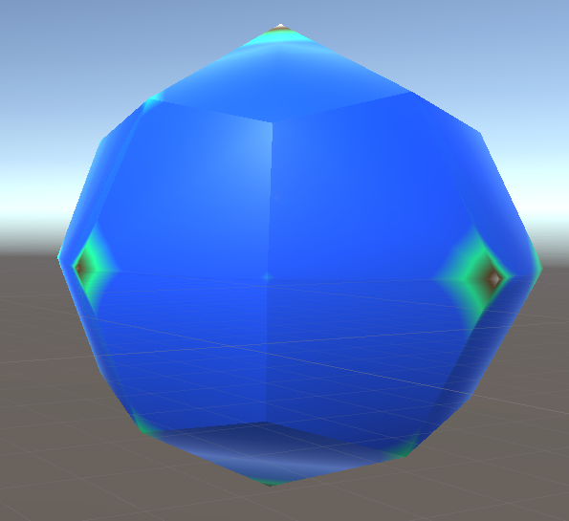 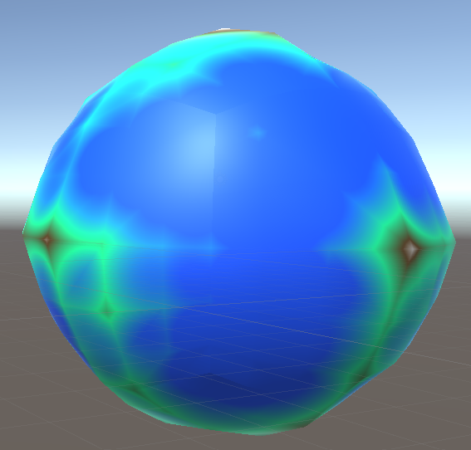 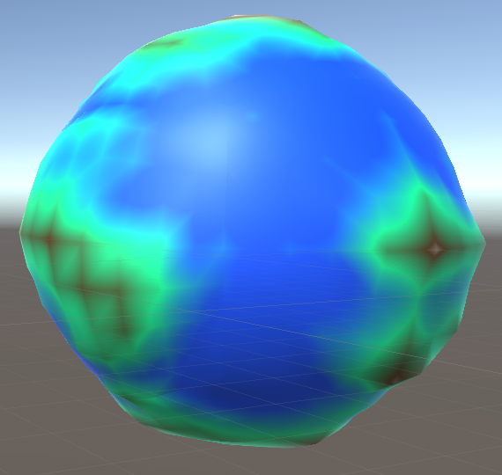

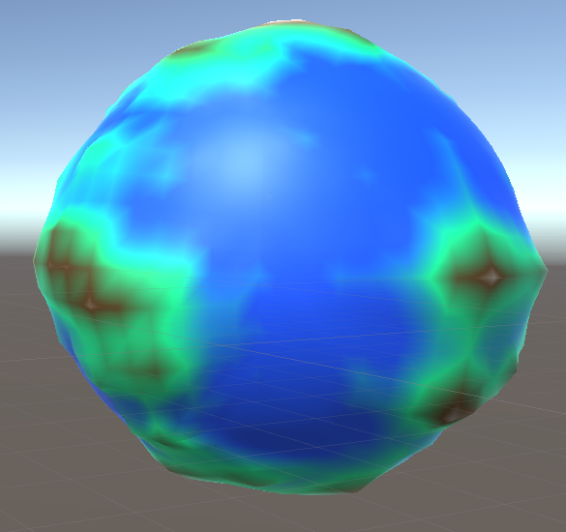 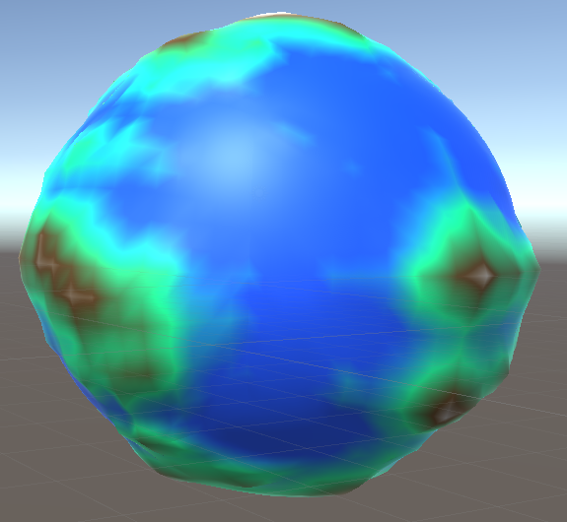 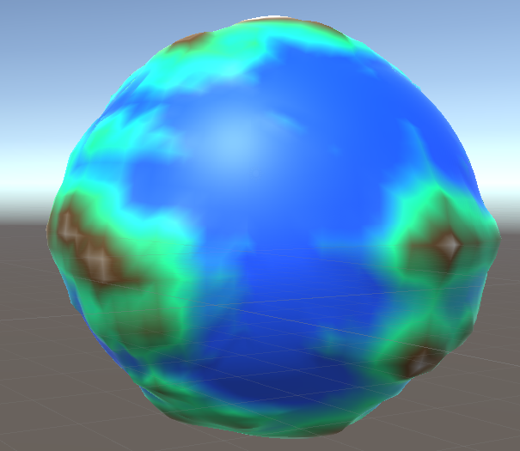

Figure : The default planet at chunk resolutions of 2, 4, 6, 8, 10 and 12, with the player camera 80 units away

### 4.2.3 Noise Function Comparison

Now that the performance impact of each of the planet and benchmark settings had been established using Perlin Noise, it was time to test the improvements in frames per second achievable by switching to Simplex Noise. It was already established in both research and development that Simplex Noise performs significantly better at 3 dimensions, but the true impact on the tool performance needs to be measured. The Simplex Noise results also give data which is relevant to real-world use of the tool, as its use is recommended. The movement benchmark and entirely default settings were used, other than chunk resolution and number of noise layers which were variables for the test.

Figure : Chart showing average FPS in movement benchmark, with different noise configurations

As shown in the chart, Simplex Noise performs considerably faster at higher chunk resolutions or number of noise layers, remaining much closer to the performance ceiling which is consistent across both techniques. This is because the function is much more optimised for three dimensions. The same pattern of performance drop-off applies to both noise functions, it is just less extreme for Simplex Noise.

The Simplex Noise results show that the tool can maintain an average frame rate of over double the 60 FPS threshold no matter the other settings, which is data which can be applied to real world uses for games typically running on more powerful hardware than the testing laptop. As explained in the previous tests, there is a significant reduction in frame rate when the camera gets close to the planet, but with Simplex Noise this reduction is far less impactful.

## 4.3 Evaluation

The broad testing of the planet tool has enabled the identification of parameters which have a significant impact on performance, by primarily focusing on the average FPS achievable with different settings. The Stationary Optimisation Change had a major impact on performance in the stationary benchmark, showing why such a simple change is so valuable for certain uses such as planets for a space background scene which rarely moves. The ‘Chunk Resolution’ and ‘Number of Noise Layers’ settings greatly affect performance as expected, due to being factors which scale up the computation required to generate the planet every time it is updated. The other planet script settings have little to no impact on performance, only affecting the appearance of the planet. In summary, this means that developers can fine tune the visual-only settings to get their desired look, and then use the performance-related settings to find a balance between visual quality and achievable frame rate. The features and settings enable the tool to fulfil Design Requirements 1 to 4.

Simplex Noise is strongly recommended for real-world use due to its significantly better performance, which is a result of optimisations made to the algorithm for use at higher dimensions. Developers will have more than sufficient performance headway for use in PC or console games, as shown by the benchmark results of between 120 and 165 FPS in the Simplex tests running on a laptop device which is underpowered in comparison. Results on this device peaked at approximately 180 and 160 FPS in the stationary and movement benchmarks respectively, and when using Simplex Noise planets viewed from a suitable distance can be generated and rendered at a frame rate that is well above the 60 FPS threshold for playability. Therefore Design Requirement 5 is successfully met.

However, the performance does suffer when the player camera is very close to the planet and is moving. This is because the planet needs to be updated due to potential consequences for the level of detail system if the camera distance to the planet changes, which is the same system causing such poor performance up close. Steps can be taken to resolve this problem, such as reducing the planet update frequency or lowering the number of detail levels within the system so that the maximum number of chunks to generate is lower. The default value of 10 distinct levels can be greatly reduced for most uses without any issues, but if a developer wants players to be able to land on the planets then the number must remain reasonably high or the quality will not be pleasing to look at and traverse. As such, a more elaborate optimisation could be looked at to further improve performance across the board. In its current state the tool performs to a very high standard on laptop hardware though, and efficiently produces visually appealing planets which could prove useful for many purposes within games.

The testing performed on the tool in this section was far from exhaustive, and larger scale testing on a variety of hardware configurations with multiple repetitions of each test would provide more complete results. The aim of this testing was to cover a range of factors which may or may not affect performance, and this was done successfully despite those limitations. More extensive and thorough testing would require more time and resources, which are the main constraining factors on the project so had to be distributed wisely throughout the entire process.

Overall the design and engineering approach taken was successful, and was appropriate to the specific project. The heavy focus placed on prototyping at the start created a foundation of knowledge and barebones code which could be built off of for the remainder of the project, and the constant testing and iteration helped to steer development towards a successful and performant tool. The final testing within this section acted as a goal during the implementation, as the performance of the tool is integral to the project and so a great deal of consideration was paid to optimisation.

# **5. Conclusions**

## 5.1 Satisfaction of Aim and Objectives

The overall aim of this dissertation was to create and demonstrate a procedural tool to automatically generate large-scale alien planets within the Unity game engine, and this was broken down into four objectives that each consisted of a crucial aspect of the project. As such, this conclusion on achievements will be largely based upon the extent to which each objective was completed.

***1: ‘Analyse the algorithms and techniques used in literature and in existing implementations of procedural mesh and terrain generation to inform the development of the tool’***

This objective was covered within the background section, and after identifying that the primary algorithm driving most procedural generation implementations was a noise function, various types were researched and analysed in detail to determine which would be best suited for use within the planet tool. A comprehensive analysis of relevant noise functions was performed, as well as extensive research into their application to terrain and planet generation. This background work culminated in the decision to include both Perlin and Simplex Noise implementations within the tool, with Simplex being recommended due to drastically improving performance. Therefore this objective was met in its entirety as evidenced by the collation of information in the background section, as well as by the visually appealing and customisable noise within the tool which showcases the application of the techniques learned.

***2: ‘Implement a procedural planet generation tool within the Unity game engine’***

The implementation-based objective was also successfully completed, as a tool was created to procedurally generate planets automatically using a 3D noise function to provide elevation data for mountains, continents and oceans. This tool was bolstered with additional features that improved the visual quality of the planets, such as the quadtree level of detail system which breaks the planet surface into chunks so that its quality can be scaled based on the distance it is being viewed from. Overlapping triangles were implemented to resolve the issue of visible seams between chunks in the lighting which was caused by this system, by extending the edges of each chunk so that they could overlap with one another for the purpose of normal calculation. This meant that there would be smooth and seamless transitions between chunks as the normals as the true border would include the overlapping triangles in their calculation, and these additional triangles were removed from the mesh before rendering. These features allow the tool to produce visually appealing planets of scalable quality, and make its implementation a complex technical achievement. The fulfilment of Design Requirements 1 to 4 is showcased by the features and functionality described.

***3: ‘Demonstrate the planet tool features by creating a menu where the planet settings can be edited, with changes showcased in real time within a navigable demonstration scene’***

The decision to reduce the scope of this objective, as mentioned in section 1.3, proved to be pivotal to the success of the project, as there would not have been time to create an additional complex procedural system during development. It was far more productive to focus entirely on the planet tool so that it could be made as powerful and feature-rich as possible, and revisit the solar system generator concept further down the line outside the scope of this project. The final version of Objective 3 was met successfully, as evidenced by the screenshots showing the demonstration scene and settings menu which were used for testing and will be included within the eventual release of the tool.

***4: ‘Optimise the generation and rendering of the planets to be as efficient as possible so that a consistent frame rate can be maintained at runtime’***

The optimisation of the planet tool was crucial as it needs to be able to be used within games while maintaining a consistent and playable frame rate, and must fulfil Design Requirement 5. Optimisations such as the Stationary Optimisation Change were made, which was a simple change from updating the planet constantly to only updating when the player position changes or a planet setting is adjusted. This greatly improved performance when the player camera is stationary as no updates are needed, and this was shown through the stationary benchmark testing in section 4.2.1. However this change is only impactful for specific applications where the planet does not need regular updates, and for many games this will not be the case.

The movement tests in section 4.2.2 and 4.2.3 show that the tool can maintain high average FPS within the demonstration scene, particularly when using Simplex Noise, and this performance can be further improved by reducing the chunk resolution or number of noise layers used for the planet surface. The successful completion of Design Requirement 5 is shown by these tests. However performance does suffer when the camera is close to the planet, so for uses where players need to be able to land on them, either a lower number of detail level increments or less frequent planet updates is recommended to maintain a playable frame rate at all times. The values of 10 detail levels and planet update checks every 0.2 seconds used for testing are very demanding, and could be reduced without too much of an impact on quality or playability. The results of this testing shown within section 4.2 are evidence for the achievements of the optimisation done, and while the performance is excellent the majority of the time, further improvements could be made.

## 5.2 Reflection and Personal Development

Over the course of the project a great deal was learned about the topic of procedural generation and the underlying techniques which are involved. The structure of the development process used enabled this learning, with the research and prototyping stages allowing me to build a foundation of knowledge which would be applied during the core implementation phase. Overall I feel that the project went well and correct decisions were made with regards to project choice, planning and implementation, with the necessary adjustments made along the way keeping progress on track. If the project were to be done again, I would be more focused and specific with my goal from the outset, as the initial objective to implement a procedural solar system generator as well as the planet tool was overly ambitious. The time spent planning and researching for this could have been better utilised, and time management could certainly have been improved overall by allocating more time to evaluation and testing. This could have allowed me to seek external feedback on the tool to include within this dissertation, or to perform more thorough testing under a wider range of conditions.

## 5.3 Future Work

Further developments are planned for the project in several key areas, with a focus on improving performance and adding additional features to the tool:

1. Implement occlusion culling so that only chunks which are currently visible to the player are rendered, which would greatly improve performance by preventing unnecessary computation of mesh data on the opposite side of the planet.
2. Add options for combining different biomes within a planet, rather than having uniform colouring and terrain geometry across the whole surface. For example, a planet could have flat green grassland areas, steep snow-covered mountains and desert regions all in different areas of its surface.
3. Add additional features to increase visual complexity, such as more realistic water which can be rendered when close to the planet, craters which can be added to the surface, and planetary rings which are visible from long distances away.
4. Further optimise the planet generation to achieve higher frames per second in benchmarks and real-world use.

An additional long-term goal is to eventually use the completed planet tool within a procedural solar system generator in order to automatically create high-quality space environments.

# **References**

|  |  |
| --- | --- |
| [1] | *“The algorithms of No Man’s Sky*,” Rambus, [Online]. Available: https://www.rambus.com/blogs/the-algorithms-of-no-mans-sky-2/ [Accessed 18 Feb. 2023]. |
| [2] | *“Value Noise and Procedural Patterns: Part 1,”* scratchapixel.com, [Online]. Available: https://www.scratchapixel.com/lessons/procedural-generation-virtual-worlds/procedural-patterns-noise-part-1/introduction.html [Accessed 15 Feb. 2023]. |
| [3] | *“File:Texture+Mapping.jpg,”* Wikipedia, [Online]. Available: https://commons.wikimedia.org/wiki/File:Texture%2BMapping.jpg [Accessed 21 Feb. 2023]. |
| [4] | *“Noise in Computer Graphics- A brief introduction,”* Harold Serrano, 2015. [Online]. Available: https://www.haroldserrano.com/blog/noise-in-computer-graphics-a-brief-introduction#:~:text=A%20noise%20function%20is%20a,(PRN)%20in%20the%20domain [Accessed 20 Feb. 2023]. |
| [5] | T. Archer, *“Procedurally Generating Terrain,”* 2011. [Online]. Available: https://micsymposium.org/mics_2011_proceedings/mics2011_submission_30.pdf [Accessed 9 Feb. 2023]. |
| [6] | *“Diamond-square algorithm,”* Wikipedia, [Online]. Available: https://en.wikipedia.org/wiki/Diamond-square_algorithm [Accessed 19 Feb. 2023]. |
| [7] | *“Understanding Perlin Noise,”* adrian's soapbox, [Online]. Available: https://adrianb.io/2014/08/09/perlinnoise.html [Accessed 23 Feb. 2023]. |
| [8] | K. Perkin, *“Improving noise,”* 2002. [Online]. Available: https://dl.acm.org/doi/abs/10.1145/566654.566636 [Accessed 10 Feb. 2023]. |
| [9] | S. Gustavson, *“Simplex noise demystified,”* 2005. [Online]. Available: https://www.researchgate.net/publication/216813608_Simplex_noise_demystified [Accessed 25 Feb. 2023]. |
| [10] | *“computergraphics.stackexchange,”* Stack Exchange, 14 June 2016. [Online]. Available: https://computergraphics.stackexchange.com/questions/3608/benefit-of-perlin-noise-over-value-noise [Accessed 25 Feb. 2023]. |
| [11] | *“Perlin VS. Simplex,”* bit-101, [Online]. Available: https://www.bit-101.com/blog/2021/07/perlin-vs-simplex/#:~:text=Simplex%20noise%20has%20a%20lower,of%20classic%20(Perlin)%20noise [Accessed 19 Feb. 2023]. |
| [12] | *“File:Euler characteristic hypercube simplex.svg,”* [Online]. Available: https://commons.wikimedia.org/wiki/File:Euler_characteristic_hypercube_simplex.svg [Accessed 26 Feb. 2023]. |
| [13] | T. Rose and A. G. Bakaoukas, *“Algorithms and Approaches for Procedural Terrain Generation - A Brief Review of Current Techniques,”* 2016. [Online]. Available: https://www.researchgate.net/publication/309222205_Algorithms_and_Approaches_for_Procedural_Terrain_Generation_-_A_Brief_Review_of_Current_Techniques [Accessed 3 Feb. 2023]. |
| [14] | *“Mitchell Clarke Next Gen Games,”* [Online]. Available: https://mitchellnextgengames.wordpress.com/2015/10/23/polygons/ [Accessed 22 Feb. 2023]. |
| [15] | *“Unity Manual,”* Unity Technologies, [Online]. Available: https://docs.unity3d.com/420/Documentation/Manual/PrimitiveObjects.html [Accessed 22 Feb. 2023]. |
| [16] | *“Unity Answers,”* Unity Technologies, 6 Feb 2016. [Online]. Available: https://answers.unity.com/questions/1138475/create-a-wireframe-shader-with-shader-forge.html [Accessed 26 Feb. 2023]. |
| [17] | R. MacWha, *“Generating Digital Worlds Using Perlin Noise,”* 2021. [Online]. Available: https://medium.com/nerd-for-tech/generating-digital-worlds-using-perlin-noise-5d11237c29e9 [Accessed 28 Feb. 2023]. |
| [18] | R. J. Vitacion and L. Liu, *“Procedural Generation of 3D Planetary-Scale Terrains,”* 2019. [Online]. Available: https://ieeexplore.ieee.org/document/8863868 [Accessed 5 Feb. 2023]. |
| [19] | *“Simplex Noise,”* Catlike Coding, [Online]. Available: https://catlikecoding.com/unity/tutorials/pseudorandom-noise/simplex-noise/ [Accessed 25 Feb. 2023]. |
| [20] | S. O'Neil, *“A Real-Time Procedural Universe, Part One: Generating Planetary Bodies,”* GameDeveloper, 2001. [Online]. Available: https://www.gamedeveloper.com/programming/a-real-time-procedural-universe-part-one-generating-planetary-bodies [Accessed 1 Feb. 2023]. |
| [21] | *“Unity Manual,”* Unity Technologies, [Online]. Available: https://docs.unity3d.com/ScriptReference/Mathf.PerlinNoise.html [Accessed 27 Feb. 2023]. |
| [22] | *“Blender 3.5 Manual,”* Blender, [Online]. Available: https://docs.blender.org/manual/en/latest/modeling/meshes/primitives.html#uv-sphere [Accessed 27 Feb. 2023]. |
| [23] | *“3 Ways To Make Blender Quad Sphere,”* [Online]. Available: https://cgian.com/2022/09/blender-quad-sphere [Accessed 28 Feb. 2023]. |
| [24] | D. Sieger, *“Generating Meshes of a Sphere,”* [Online]. Available: https://www.danielsieger.com/blog/2021/03/27/generating-spheres.html [Accessed 28 Feb. 2023]. |
| [25] | E. Garofalo, *“What Is the Difference Between a UV Sphere and an Icosphere in Blender?,”* makeuseof.com, 2022. [Online]. Available: https://www.makeuseof.com/uv-sphere-icosphere-blender/#:~:text=This%20type%20of%20mesh%20works,even%20botanicals%20like%20succulent%20plants. [Accessed 28 Feb. 2023]. |
| [26] | D. Sieger, *“Generating Platonic Solids in C++,”* [Online]. Available: https://www.danielsieger.com/blog/2021/01/03/generating-platonic-solids.html [Accessed 25 Feb. 2023]. |
| [27] | *“Unity Answers,*” Unity Technologies, 5 April 2015. [Online]. Available: https://answers.unity.com/questions/938178/3d-perlin-noise.html [Accessed 23 Feb. 2023]. |
| [28] | “*GitHub Gist,”* 2015. [Online]. Available: https://gist.github.com/digitalshadow/134a3a02b67cecd72181 [Accessed 1 Mar. 2023]. |
| [29] | J. Trinh, *“Partitioning 2D Spaces: An Introduction to Quadtrees,”* 2020. [Online]. Available: https://medium.datadriveninvestor.com/partitioning-2d-spaces-an-introduction-to-quadtrees-d95728856613 [Accessed 1 Mar. 2023]. |
| [30] | *“Procedural Grid,”* Catlike Coding, [Online]. Available: https://catlikecoding.com/unity/tutorials/procedural-grid/ [Accessed 26 Feb. 2023]. |
| [31] | *“Perlin Noise: Part 2,”* scratchapixel.com, [Online]. Available: https://www.scratchapixel.com/lessons/procedural-generation-virtual-worlds/perlin-noise-part-2/perlin-noise-terrain-mesh.html [Accessed 26 Feb. 2023]. |

# **Appendix A**

Benchmark script code

# 

# **Appendix B**

Full Testing

**Stationary Benchmarks**

Distance: 80 Units

|  |  |  |  |  |  |  |
| --- | --- | --- | --- | --- | --- | --- |
| Chunk Resolution | Min FPS (Disabled) | Min FPS (Enabled) | Max FPS (Disabled) | Max FPS (Enabled) | Avg FPS (Disabled) | Avg FPS (Enabled) |
| 2 | 29.0 | 34.3 | 459.1 | 465.2 | 174.9 | 176.7 |
| 4 | 28.2 | 33.7 | 389.9 | 424.9 | 175.4 | 176.5 |
| 6 | 28.7 | 34.2 | 410.0 | 455.3 | 174.4 | 176.9 |
| 8 | 27.4 | 35.4 | 399.0 | 413.7 | 174.7 | 176.2 |
| 10 | 40.4 | 36.8 | 400.4 | 398.3 | 173.8 | 175.6 |
| 12 | 34.9 | 37.5 | 398.5 | 396.8 | 176.0 | 175.6 |

Distance: 40 Units

|  |  |  |  |  |  |  |
| --- | --- | --- | --- | --- | --- | --- |
| Chunk Resolution | Min FPS (Disabled) | Min FPS (Enabled) | Max FPS (Disabled) | Max FPS (Enabled) | Avg FPS (Disabled) | Avg FPS (Enabled) |
| 2 | 35.3 | 40.3 | 468.7 | 421.1 | 178.6 | 178.8 |
| 4 | 26.0 | 28.1 | 465.4 | 428.5 | 176.5 | 176.0 |
| 6 | 41.4 | 52.0 | 448.6 | 422.2 | 177.5 | 178.8 |
| 8 | 33.9 | 34.1 | 496.7 | 456.2 | 174.6 | 175.5 |
| 10 | 21.6 | 41.0 | 454.6 | 393.0 | 161.3 | 176.3 |
| 12 | 19.5 | 54.8 | 488.0 | 385.5 | 155.0 | 175.9 |

Distance: 20 Units

|  |  |  |  |  |  |  |
| --- | --- | --- | --- | --- | --- | --- |
| Chunk Resolution | Min FPS (Disabled) | Min FPS (Enabled) | Max FPS (Disabled) | Max FPS (Enabled) | Avg FPS (Disabled) | Avg FPS (Enabled) |
| 2 | 49.5 | 43.1 | 450.4 | 453.6 | 177.8 | 179.2 |
| 4 | 28.2 | 43.5 | 444.8 | 423.5 | 170.1 | 177.2 |
| 6 | 19.0 | 29.0 | 455.5 | 418.4 | 152.8 | 175.1 |
| 8 | 13.5 | 38.6 | 516.7 | 412.6 | 134.5 | 175.3 |
| 10 | 11.8 | 34.6 | 552.7 | 367.0 | 116.0 | 174.2 |
| 12 | 8.8 | 29.7 | 575.2 | 361.1 | 88.1 | 175.1 |

Distance: 10 Units

|  |  |  |  |  |  |  |
| --- | --- | --- | --- | --- | --- | --- |
| Chunk Resolution | Min FPS (Disabled) | Min FPS (Enabled) | Max FPS (Disabled) | Max FPS (Enabled) | Avg FPS (Disabled) | Avg FPS (Enabled) |
| 2 | 24.3 | 35.0 | 490.8 | 446.6 | 164.6 | 179.4 |
| 4 | 12.6 | 43.2 | 495.5 | 385.3 | 127.1 | 175.6 |
| 6 | 8.2 | 33.0 | 576.0 | 401.5 | 70.1 | 174.7 |
| 8 | 5.3 | 34.2 | 569.2 | 419.4 | 31.9 | 174.3 |
| 10 | 3.9 | 50.7 | 4.3 | 379.7 | 4.2 | 175.2 |
| 12 | 3.0 | 36.2 | 3.2 | 383.4 | 3.1 | 175.6 |

**Movement Benchmarks**

**Chunk Resolution**

Default Settings Configuration

|  |  |  |  |
| --- | --- | --- | --- |
| Chunk Resolution | Min FPS | Max FPS | Average FPS |
| 2 | 27.0 | 474.8 | 160.4 |
| 4 | 15.3 | 480.1 | 156.7 |
| 6 | 8.6 | 470.8 | 153.0 |
| 8 | 6.2 | 509.5 | 143.5 |
| 10 | 4.0 | 550.2 | 131.6 |
| 12 | 3.2 | 462.1 | 123.3 |

Baseline Configuration

|  |  |  |  |
| --- | --- | --- | --- |
| Chunk Resolution | Min FPS | Max FPS | Average FPS |
| 2 | 25.0 | 413.6 | 159.2 |
| 4 | 13.5 | 431.1 | 157.7 |
| 6 | 8.5 | 459.1 | 151.6 |
| 8 | 5.5 | 496.0 | 140.3 |
| 10 | 3.9 | 417.4 | 131.6 |
| 12 | 3.0 | 459.0 | 122.0 |

Maximum Value Configuration

|  |  |  |  |
| --- | --- | --- | --- |
| Chunk Resolution | Min FPS | Max FPS | Average FPS |
| 2 | 24.4 | 535.4 | 161.6 |
| 4 | 11.9 | 481.9 | 154.4 |
| 6 | 7.3 | 496.0 | 147.1 |
| 8 | 5.3 | 550.1 | 139.5 |
| 10 | 3.7 | 534.2 | 132.1 |
| 12 | 3.0 | 506.1 | 124.4 |

Minimum Value Configuration

|  |  |  |  |
| --- | --- | --- | --- |
| Chunk Resolution | Min FPS | Max FPS | Average FPS |
| 2 | 27.7 | 463.5 | 158.7 |
| 4 | 15.2 | 523.3 | 157.4 |
| 6 | 9.3 | 491.3 | 149.5 |
| 8 | 5.7 | 483.6 | 144.0 |
| 10 | 3.2 | 367.2 | 123.9 |
| 12 | 3.2 | 452.3 | 121.6 |

**Number of Layers**

Chunk Res 8

|  |  |  |  |
| --- | --- | --- | --- |
| Number of Layers | Min FPS | Max FPS | Average FPS |
| 2 | 7.0 | 427.6 | 148.0 |
| 3 | 5.6 | 440.1 | 139.7 |
| 4 | 4.7 | 422.6 | 133.1 |
| 5 | 3.6 | 451.0 | 126.4 |
| 6 | 3.0 | 475.3 | 127.1 |
| 7 | 3.0 | 545.5 | 122.0 |
| 8 | 3.0 | 438.8 | 111.2 |

Chunk Res 2

|  |  |  |  |
| --- | --- | --- | --- |
| Number of Layers | Min FPS | Max FPS | Average FPS |
| 2 | 21.5 | 460.9 | 161.2 |
| 3 | 23.2 | 435.5 | 162.8 |
| 4 | 20.2 | 479.1 | 157.6 |
| 5 | 15.5 | 466.8 | 157.2 |
| 6 | 15.8 | 484.8 | 157.8 |
| 7 | 13.1 | 548.9 | 158.1 |
| 8 | 10.5 | 413.4 | 154.7 |

Chunk Res 12

|  |  |  |  |
| --- | --- | --- | --- |
| Number of Layers | Min FPS | Max FPS | Average FPS |
| 2 | 4.2 | 468.2 | 132.7 |
| 3 | 3.1 | 444.1 | 121.9 |
| 4 | 3.0 | 481.5 | 118.7 |
| 5 | 3.0 | 507.7 | 113.8 |
| 6 | 3.0 | 484.1 | 106.8 |
| 7 | 3.0 | 494.9 | 98.1 |
| 8 | 3.0 | 474.1 | 94.1 |

**Benchmark Settings**

Default settings

|  |  |  |  |
| --- | --- | --- | --- |
| Chunk Resolution | Min FPS | Max FPS | Average FPS |
| 2 | 27.0 | 474.8 | 160.4 |
| 4 | 15.3 | 480.1 | 156.7 |
| 6 | 8.6 | 470.8 | 153.0 |
| 8 | 6.2 | 509.5 | 143.5 |
| 10 | 4.0 | 550.2 | 131.6 |
| 12 | 3.2 | 462.1 | 123.3 |

Default, no wait (25s duration, 0s wait)

|  |  |  |  |
| --- | --- | --- | --- |
| Chunk Resolution | Min FPS | Max FPS | Average FPS |
| 2 | 27.9 | 493.4 | 160.0 |
| 4 | 15.2 | 536.0 | 154.0 |
| 6 | 9.1 | 487.4 | 150.1 |
| 8 | 6.3 | 499.4 | 139.8 |
| 10 | 4.2 | 462.2 | 129.9 |
| 12 | 3.1 | 527.0 | 116.2 |

No wait, 25s duration, 1.5 speed, 40 distance

|  |  |  |  |
| --- | --- | --- | --- |
| Chunk Resolution | Min FPS | Max FPS | Average FPS |
| 2 | 22.6 | 514.9 | 155.1 |
| 4 | 14.6 | 490.7 | 147.9 |
| 6 | 9.0 | 488.9 | 130.2 |
| 8 | 5.9 | 544.7 | 108.5 |
| 10 | 4.0 | 500.4 | 85.7 |
| 12 | 3.0 | 442.0 | 67.2 |

No wait, 25s duration, 0.75 speed, 20 distance

|  |  |  |  |
| --- | --- | --- | --- |
| Chunk Resolution | Min FPS | Max FPS | Average FPS |
| 2 | 18.4 | 523.5 | 149.8 |
| 4 | 14.5 | 470.3 | 128.9 |
| 6 | 8.7 | 500.6 | 96.7 |
| 8 | 5.6 | 509.7 | 63.2 |
| 10 | 3.8 | 470.1 | 30.3 |
| 12 | 3.0 | 448.9 | 18.8 |

**Noise Function Comparison (Movement Benchmark)**

Default settings – Perlin

|  |  |  |  |
| --- | --- | --- | --- |
| Chunk Resolution | Min FPS | Max FPS | Average FPS |
| 2 | 23.2 | 435.5 | 162.8 |
| 4 | 14.6 | 455.5 | 155.4 |
| 6 | 8.0 | 532.3 | 150.0 |
| 8 | 5.6 | 440.1 | 139.7 |
| 10 | 4.0 | 419.1 | 131.8 |
| 12 | 3.1 | 444.1 | 121.9 |

Default settings, 8 noise layers – Perlin

|  |  |  |  |
| --- | --- | --- | --- |
| Chunk Resolution | Min FPS | Max FPS | Average FPS |
| 2 | 10.5 | 413.4 | 154.7 |
| 4 | 5.3 | 455.6 | 140.4 |
| 6 | 3.2 | 450.7 | 126.6 |
| 8 | 3.0 | 438.8 | 111.2 |
| 10 | 3.0 | 483.7 | 101.6 |
| 12 | 3.0 | 474.1 | 94.1 |

Default settings - Simplex

|  |  |  |  |
| --- | --- | --- | --- |
| Chunk Resolution | Min FPS | Max FPS | Average FPS |
| 2 | 35.0 | 470.0 | 161.6 |
| 4 | 27.6 | 476.1 | 159.3 |
| 6 | 18.5 | 475.7 | 157.7 |
| 8 | 11.4 | 412.9 | 153.6 |
| 10 | 8.5 | 428.4 | 150.3 |
| 12 | 5.6 | 446.6 | 143.9 |

Default settings, 8 noise layers – Simplex

|  |  |  |  |
| --- | --- | --- | --- |
| Chunk Resolution | Min FPS | Max FPS | Average FPS |
| 2 | 30.9 | 501.6 | 161.2 |
| 4 | 16.5 | 512.6 | 160.2 |
| 6 | 10.4 | 483.9 | 154.6 |
| 8 | 5.8 | 499.6 | 142.1 |
| 10 | 4.3 | 496.1 | 133.4 |
| 12 | 3.0 | 453.4 | 127.2 |